Description, analysis & evaluation video Worksheet
Video
Link:
Exercise 1
- Read the following sentences and identify whether they are description [D], analysis [A] or evaluation [E].

- One suggestion proposed in this paper is that the only way to control AI is to ensure that its values are our values. [ ]
- Bioengineering is the application of engineering knowledge to the fields of medicine and biology for the enhancement of human health. [ ]
- The main issue with carbon capture and storage under the ocean is that CO2 reacts with water and causes the oceans to become too acidic for marine life. [ ]

Exercise 2
- In this paragraph highlight the following sections: description, analysis, evaluation.

Smart home technology
Smart home technology can take many forms, from controlling the lighting and temperature of a room to monitoring the contents of a fridge. As most current smart homes rely on retro-fitting, which is the process of adding home automation features to an existing property and can lead to considerable costs for the homeowner, newer homes are being built with the additional sensors and systems already installed. However, as the amount of smart home devices and applications continues to grow rapidly, it has given rise to compatibility and connectivity issues. As a result, the focus should now shift to standardising the technology’s protocols.

Exercise 3
- Look at the bar chart and answer the questions.

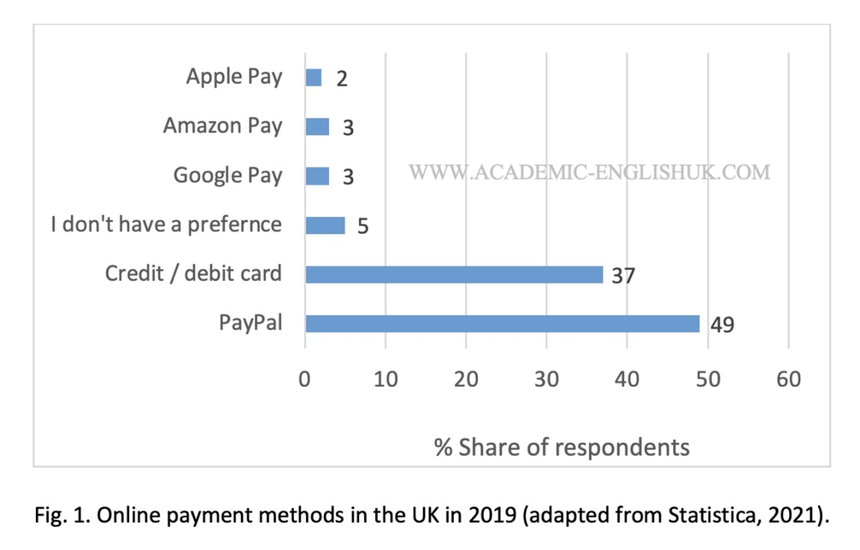

Description

i. | What does the graph show?
ii. | Which country is the chart referring to?
iii. | Which year was the data collected?

Analysis

i. | Which findings are the most significant?
ii. | How do the findings compare?
iii. | What is the reason for the trends?

Evaluation

i. | Will the findings change in the future?
ii. | How will the findings change in the future?
iii. | What’s your rationale for the changes you mentioned?

Exercise 4
- Analyse and evaluate the quote by David Attenborough (2021) for the UN COP 26 summit.

Quote: “The problems that await the world in the next five to ten years because of climate change are greater than the coronavirus pandemic”.

Exercise 5
- Analyse and evaluate the quote by M. Kit Delgado (2021), Assistant Professor of Emergency Medicine and Epidemiology at University of Pennsylvania.

Quote: “Given how beneficial these Smartphone breathalyzer devices could be to public health, our findings suggest that oversight or regulation would be valuable”.

*All answers in the video

