How to write an effective academic summary

Suggested steps in writing summaries:

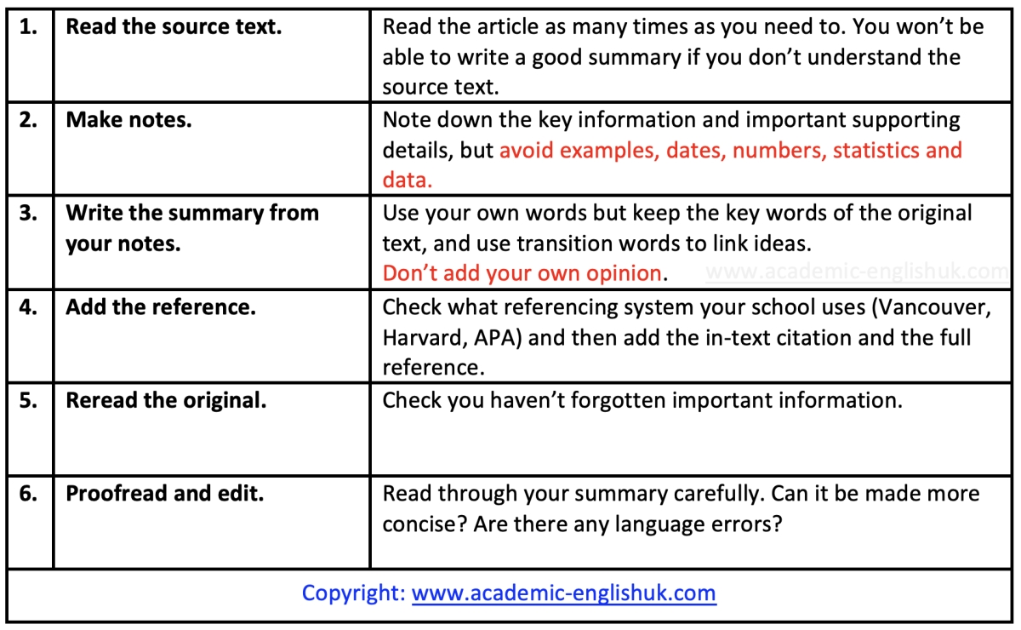

Example

Goal-setting Theory
Developed in 1968 by Edwin A Locke, goal-setting theory is based on the premise that setting specific and measurable goals is more effective than establishing unclear goals. In his article, Locke illustrates five principles for setting clear objectives. Clarity: goals need to be clear and specific. Challenge: goals should be challenging because goals that are too easy are demotivating. Commitment: People need to be committed to the goal or they are less likely to achieve the goal. Feedback: Regular feedback should be provided to ensure the individual remains on track. Task complexity: goals should be broken down into smaller goals (Wrobleski, 2019).

Sample notes
GST: specific & measurable goals more effective than unclear goals (Edwin A Locke, 1968).
5 princ.:
- Clarity: goals = clear & specif (Wrobleski, 2019).
- Chall: Not too easy à demot.
- Commit: No commit., no achieve.
- FB: provide fb reg.
- Task complex.: Div. tasks into manageable tasks.

Possible summary on Goal-setting Theory
Drawing on the work of Edwin A Locke, Wrobleski (2019) defines goal setting theory as an idea where setting specific and measurable goals is more productive than specifying unclear goals. There are five fundamentals for setting clear aims: clarity, challenge, commitment, feedback and task complexity.

Taken from: Introduction to Summary Writing: 1A General Academic – lesson link

Exercise 1: Guided Practice
Task
- Write a summary of between 30-50 words of the following paragraph using the ‘suggested steps in writing summaries’.

Democratizing IT
Data democratization refers to the process of making digital information available and accessible to everyone within an organisation, regardless of their technical know-how. It means empowering employees to work with data, understand data and make faster data-informed decisions. According to Marr (2021), when staff members are given access to the organisation’s data, operations become more streamlined and efficient as those who know the business will not have to wait for data scientists to analyse the data for them. However, organisations who democratize data need to have a strong leadership in place to ensure the data is properly managed.

Note-taking area

Summary

Taken from: Introduction to Summary Writing: 1B Business – lesson link

Exercise 2: Guided Practice
Task
- You’re going to write a summary of between 30-50 words of the following paragraph using the ‘suggested steps in writing summaries’.

Behavioural economics
Behavioural economics is a field of economics that incorporates the studies of psychology, neuroscience and sociology to better understand the decision-making processes of individuals (The Observer, 2017). This fairly new subject aims to gain a deeper understanding of why people, at times, make choices that are irrational and the thoughts and emotions that underpin the decisions made (The Guardian, 2017). Decisions, according to Samson (2018), such as whether to pay more for a certain brand, how much to spend on a holiday and which candidate to support in a public vote all involve a decision-making process and it is this mechanism that behavioural economists attempt to understand in order to predict human behaviour.

Note-taking area

Summary

Taken from: Introduction to Summary Writing: 1C STEM – lesson link

