Fact vs Opinion Video Worksheet
Definition

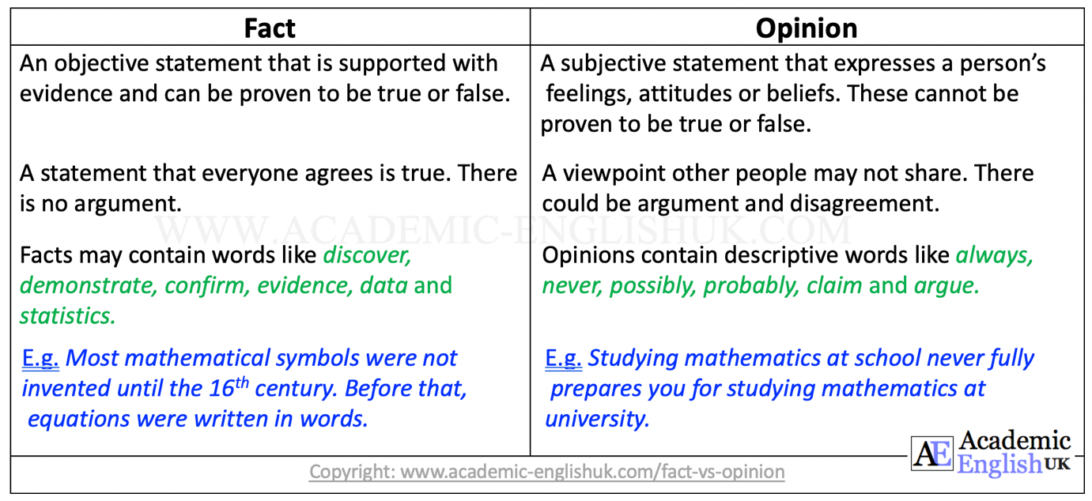

Language Focus

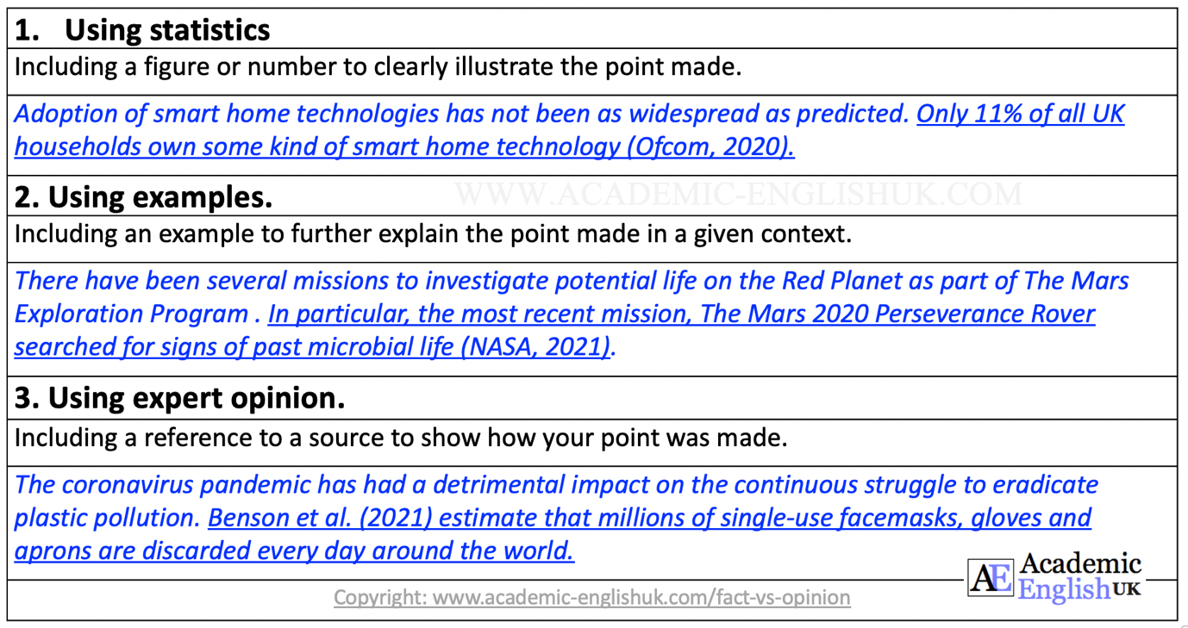

Exercise 1:
Answer the questions about fact and opinion:

- When reading, how can you tell whether a statement is a fact or an opinion?

- What makes distinguishing between facts and opinions so difficult?

- If you are unsure if a statement is a fact, what could you do to find out?

- Why is it important to be able to distinguish between facts and opinions?

Exercise 2
Read the following sentences and identify which of the following sentences are facts and which are opinions.

1. Dave Asprey’s ‘upgrade labs’ help you to achieve peak performance, improve cognition and enhance longevity. Fact or Opinion

2. The Romans didn’t consider 0 to be a number. That’s why there are no zeros in Roman numerals. Fact or Opinion

3. Knowledge of Newtonian physics is completely irrelevant for people who wish to study quantum mechanics. Fact or Opinion

Exercise 3
Read the paragraph on paleo diet and decide if each statement is a fact or an opinion. What helped you decide?

The Paleo Diet

The Paleo diet first gained popularity approximately 10 years ago after research undertaken by Dr Cordain to discover the optimal human diet^{i}. The diet mainly centres on consuming meat and fish, fruit and vegetables, and nuts and seeds^{ii}. Health experts consider it to be high in protein and fibre and low in carbohydrates and sugars, and it is often referred to in the field of nutrition as the ‘Stone Age’ diet as it aims to mimic what was eaten during the Paleolithic era^{iii} (The Nutrition Source, 2019).

 | Fact or Opinion | How did you know?
i.
ii.
iii.

Video
This worksheet accompanies the video: https://youtu.be/KZhCgGN9XDg

