Shanty Towns

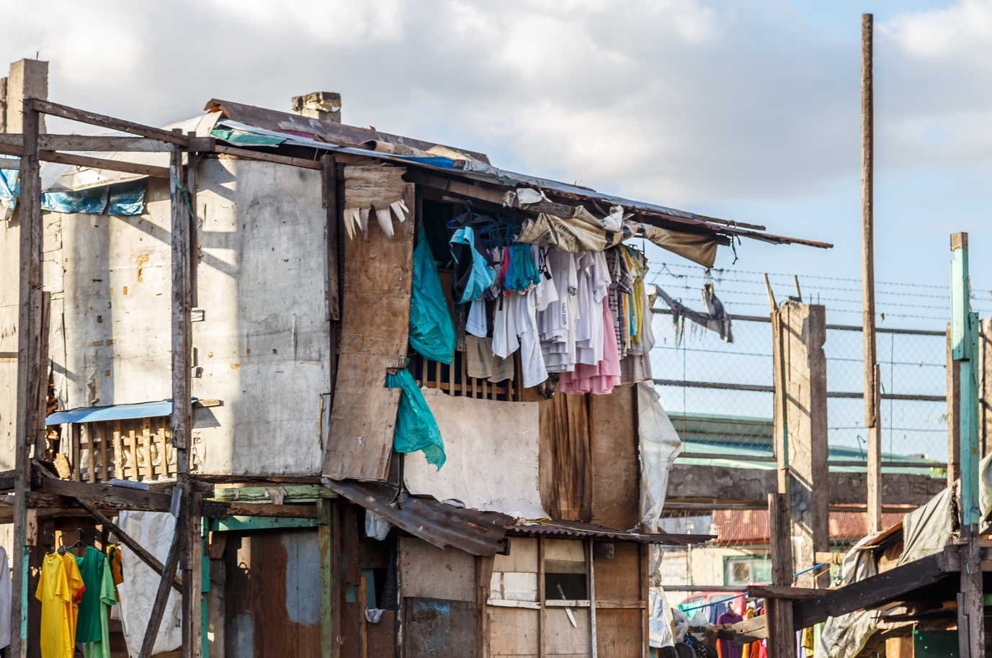
www.academic-englishUK.com

SPSE Reading Lesson

EXAMPLE

Task: Write a SPSE essay on Shanty Towns or write a SPSE essay on Shanty Towns using an outline. Read a text on Shanty Towns and fill in the outline plan. Identify the situation, key problems, possible solutions and evaluation.

Teacher’s Notes
Reading/Writing- SPSE
Time: 1+hour
Level: *****^{[/B2/C1]}
Lesson Plan
Aim: to develop the students’ reading ability to identify the situation, problems, solutions and evaluation in a text, or to develop the students’ writing skills in the construction of an SPSE essay.

Lead in
- What is a Shanty Town? Brainstorm ideas and associated vocabulary.
- Key vocab: slum, poverty, poor people, housing crisis, developing countries, Favelas, unregulated, illegal, no services, diseases, crime, unhealthy, unemployment.

SPSE Revision
- Remind students what an SPSE essay is.
- Go here: https://www.academic-englishuk.com/spse (Models / Language).

Option 1: Reading Task
- Distribute reading text and outline (blank).
- Students read text & complete the outline with situation, problems, solutions & evaluation (Allow 20 minutes).
- Feedback: distribute outline (answers) for students to check.

Option 2: Writing Task
- Distribute essay question: Shanty Towns are unhealthy environments for people to live. Check understanding.
- Students plan & write the essay. Allow 50 minutes.
- Feedback: either distribute SPSE essay outline answers & model essay for students to check themselves or take in and mark. Use error correction code:

https://www.academic-englishuk.com/error-correction

Scaffolding/differentiation
- Students use SPSE essay outline answers to write the essay.
- Key phrases sheet to support students with SPSE language at the back of this book.
Extra
- Students research another issue (homelessness, housing crisis, cost of living, unemployment, immigration) complete an SPSE outline and then write an essay.

Copyright: These materials are photocopiable but please leave all logos and web addresses on handouts. Please don’t post these materials onto the web. Thank you
Shanty Towns Writing Question
Question: Shanty Towns are unhealthy environments for people to live.
- What problems do they have?
- What are the possible solutions?
- How effective are these solutions
Answer this question and write an SPSE essay between 200 – 300 words
Time: 50 minutes
Plan (make notes here…)

Shanty Towns Text
Shanty towns are usually found in slums; the poor areas of cities in some developing countries. In recent years, XXXXXX XXXXXXXX XXXXXXX XXXX in such housing has increased dramatically. This essay will look at two specific health problems XXXXXX XXXXXXXX XXXXXXX XXXXXX and propose XXXXXX XXXXXXXX XXXXXXX XX these issues and evaluate their effectiveness.

One of the most significant problems associated with shanty towns is health-related issues. Firstly, because the XXXXXX XXXXXXXX XXXXXXX XXXXXXXX not provide clean water. As a result, this causes diseases such as dysentery, typhoid and hepatitis. Secondly, houses are often XXXXXX XXXXXXXX XXXXXXX XXXXXXXX . This makes it easier to contract diseases such as flu, TB and diphtheria where infection enters through the throat.

There are several measures which could solve these problems. One possible solution is that the XXXXXX XXXXXXXX XXXXXXX XXXXXX to individual houses or, at least, to neighbourhoods. This would make drinking water safe and reduce XXXXXX XXXXXXXX XXXXXXX XXXXXXXX could provide householders with building materials to improve their conditions and educate them XXXXXX XXXXXXXX XXXXXXX XXXXXXXX .

Although these solutions would XXXXXX XXXXXXXX XXXXXXX XXXXXXXX resistance from local XXXXXX XXXXXXXX XXXXXXX a safer, healthier environment, and would also lead to increased employment opportunities in areas such as construction and plumbing.

In conclusion, there are a number of health issues regarding the living conditions in shanty towns. In order to XXXXXX XXXXXXXX XXXXXXX XXXXXXXX allocates sufficient funding to housing projects in such areas. Only in this way can the people XXXXXX XXXXXXXX XXXXXXX XXXXXXXX their current living standards.

Words 273

Shanty Town Outline 1
Introduction | - Poor area / developing cities  - XXXXXX XXXXXXXX XXXXXXX XX  - Thesis: health problems / governmental solutions
Problems | - Illegal: XXXXXX XXXXXXXX XXXXXXX XXXXXXXX / typhoid / hepatitis)  - Over-crowding & XXXXXX XXXXXXXX XXXXXXX XXXXXXXX – flu, TB and diphtheria)
Solutions | - Governmental: XXXXXX XXXXXXXX XXXXXXX XXXXXXXX and reduce infections.  - Authorities: XXXXXX XXXXXXXX XX and education
Evaluations | - (negative) Require XXXXXX XXXXXXXX XXXXXX resistance  - (positive) Safer, healthier XXXXXX XXXXXXXX XXXXXXX XXXXXXXX and plumbing.
Conclusion | - Thesis: health issues regarding the living conditions in shanty towns.  - Main point: XXXXXX XXXXXXXX XXXXXXX XXXXXXXX projects  - Recommendation: XXXXXX XXXXXXXX XXXXXX current living standards.

Shanty Town Outline 2
Introduction

Problems

Solutions

Evaluations | - (negative)  - (positive)
Conclusion

SPSE Language Phrases
Key phrases for writing an SPSE essay
Situation
Follows the conventions of an introduction
(general > specific > definition > situation >outline)
Outline: This essay will discuss two problems, propose possible solutions and evaluate the effectiveness of these solutions.
Problems
Adjective: central / main / major / common / immediate / serious / significant.
Verbs: associate / raise / consider / discuss / address / resolve / discuss.
- The most significant problem is…
- … poses / presents an immediate problem because…
- Another possible issue is …
Cause & effect language
Leads to / results in / gives rise to / as a consequence / owing to / because of / as a result.
Cause and effect phrases
This suggests / … Is linked to / associated with / connected to …. / …may be affected by…
Solution
Adjective: long-term / short-term / proposed / effective / comprehensive / possible / practical / feasible / cost-effective / workable / realistic.
Verbs: propose / put forward / suggest / adopt / provide.
- One possible solution would be to…. / One way of solving the problem is...
- One practical approach could be to…
Evaluation [Show both positive effects and negatives]
- Implementation of these solutions would … However, …
- Although these solutions provide…, there are a number of limitations. The first one is...
- Overall, these solutions offer a range of …, but it needs to be highlighted that…
Conclusion [Make a decision]
In conclusion / to sum up / to conclude.
If clause: if these solutions are implemented, then this would …

