Plagiarism Video Worksheet
Watch the video and take notes on this worksheet

1.What is plagiarism?

2.Make notes on the eight types of plagiarism

 | Type of plagiarism | Explanation
1 | Direct plagiarism (copying / verbatim) | Direct plagiarism / word-for-word / someone else’s work / no attribution or quotation marks / no ref
2 | Mosaic plagiarism (patchwork)
3 | Source-based plagiarism
4 | Paraphrasing plagiarism
5 | Translation plagiarism
6 | Self-plagiarism
7 | Accidental plagiarism | Neglects to cite / misquotes / unintentional paraphrases a source no ref = academic offence.
8 | Plagiarism Commissioning

3. What are the eight tips to avoid plagiarism?

The top ten tips to avoid academic plagiarism
1 | Allow ample time for writing and revision.
2
3
4
5
6 | Compile your reference list as you do your research and write your paper.
7
8

4. How do universities check for Plagiarism?
Turnitin Report Example
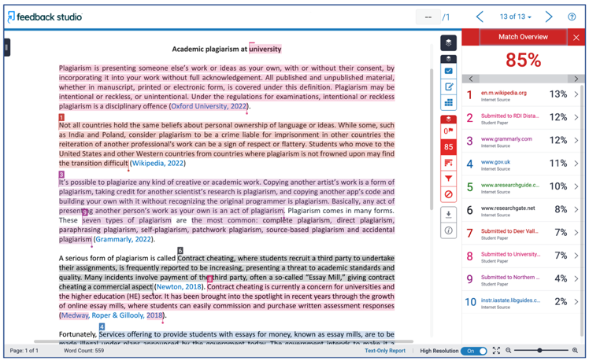

5. Plagiarism Checkers. What were the differences in these websites to Turnitin?

6. Overall summary

Video worksheet: https://youtu.be/Id2cyEBgz9I

