UK
Mental Health

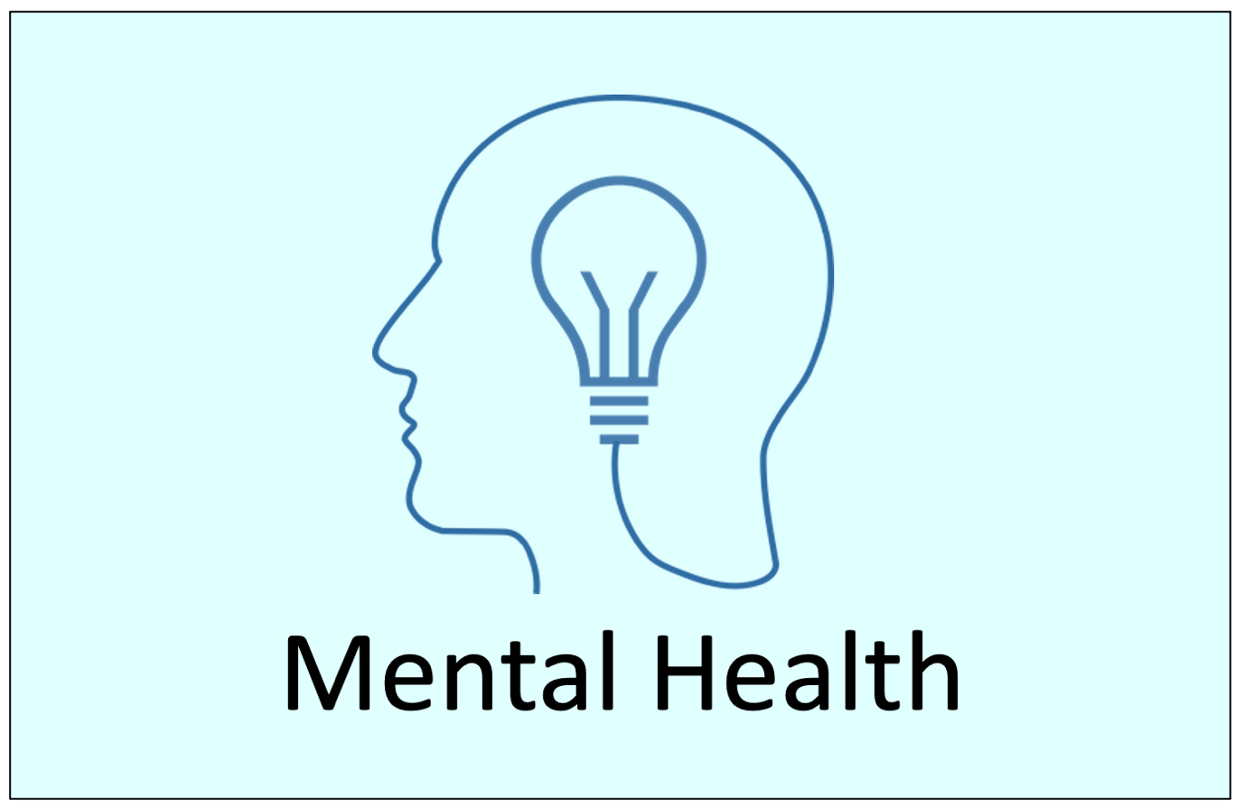

Mini Lecture
EXAMPLE

Copyright: These materials are photocopiable but please leave all logos and web addresses on handouts. Please don’t post these materials onto the web. Thank you
Lesson Plan: Mental Health EXAMPLE

Lesson: Lecture listening
Time: 1 hour
Level: *****^{[B1/ B2/C1].}

Lesson Aim:
To focus on one key topic and develop a range of key academic skills based on this topic.

Introduction [5 minutes]
- Introduce the topic ‘Mental Health’.
- Can you explain what mental health means?
- How do people in your country respond to mental health issues?

Listening: Lecture & Test Questions [30-40 minutes]

Video (03:48): Available in paid download
MP3: Available in paid download

- Give out Listening: mini lecture worksheet.
- Students check key vocabulary.

Option 1
- Students look at the questions.
- Students listen & answer the questions.
- Give 2 minutes to tidy answers.
- Students listen again. Check answers & answer missed questions.
- Feedback: distribute or project ANSWERS.
Option 2
- Students listen & take notes (use paper or the PPT slides)
- Students listen again & add to their notes.
- Students use their notes to answer the questions.
- Feedback: distribute or project ANSWERS.

Post lecture extra ideas
- Write a 100-word summary of the lecture.
- Apply critical thinking strategies to the lecture. Use this critical thinking question document: https://www.academic-englishuk.com/wp-content/uploads/2020/03/Critical-Questions-a-linear-model-AEUK.pdf (writing, presentation or seminar).
- Research other types of therapy for mental health disorders (presentation or seminar).
- Research in depth what are the main causes of depression (presentation or seminar).

Listening: Mini Lecture Worksheet
Task 1: Key vocabulary
Check these words and phrases before listening:
treatment. disorder. mental health. genetic. biological. psychological. anxiety. depression. socioeconomic status. susceptible. Buddhist. meditation. aware. therapy. derived. influence. psychotherapy. dysfunctional. therapeutic. adjustments. enhance. recurring. favourable.
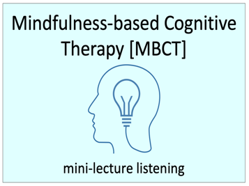
Task 2: Lecture Listening
Listen to the lecture on Mindfulness-based Cognitive Therapy [MBCT] and answer the following questions:

2.1 Open Questions
i. | How many people have mental disorders per year in England?
ii. | Name XXXXXXXXXXXXXXXXXXXXXXXXXXXXXXXXXXXXXX. | 1.  2.
iii. | How many people in Britain suffer from anxiety or depression?
iv. | Name XXXXXXXXXXXXXXXXXXXXXXXXXXXXXXXXXXXXXX? | 1.  2.
v. | How XXXXXXXXXXXXXXXXXXXXXXXXXXXXX mental health issues?
____ / 7
2.2 Multiple choice
Choose one answer only for each question.
i. | Mindfulness is a combination of… | ancient wisdom and 21st century science.
 |  | XXXXXXXXXXXXXXXXXXXXXXXXXXXXXXXXXXXXXX.
 |  | ancient wisdom and 20th century science.
ii. | Mindfulness XXXXXXXXXXXXXXXXXXXXX of our… | XXXXXXXXXXXXXXXXXXXXXXXXXXXXXXXXXXXXXX
 |  | thoughts, feelings and meditation.
 |  | XXXXXXXXXXXXXXXXXXXXXXXXXXXXXXXXXXXXXX
iii. | CBT is a type of… | sociology.
 |  | XXXXXXXXXXXXXXXXXXXXXXXXXXXXXXXXXXXXXX
 |  | psychology.
iv. | CBT was developed in the… | 1950s.
 |  | XXXXXXXXXXXXXXXXXXXXXXXXXXXXXXXXXXXXXX
 |  | 1970s.
v. | MBCT XXXXXXXXXXXXXXXXXXXXXX … | XXXXXXXXXXXXXXXXXXXXXXXXXXXXXXXXXXXXXX
 |  | mediation and quality of life strategies.
 |  | quality of life strategies and thinking patterns.
____ / 5
2.3 Gap Fill
i)How does MBCT help people with recurring depression? Complete the gaps. The first letter is already given.
MBCT has shown to be b_________________ as XXXXXXXXXXXXXXXXXXXXXXXXXXXXXXXXXXXXXX f__________________ at the first sign of depression.

____ / 2
Total Score ___ /14
PowerPoint Slides
Listen to the lecture and take notes using the PPT slides

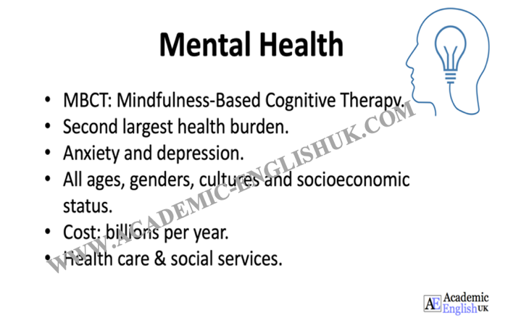
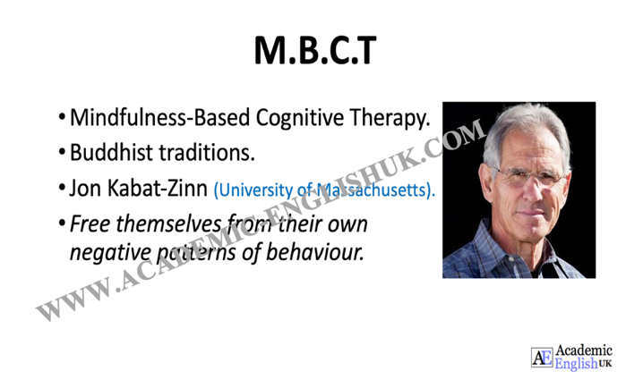
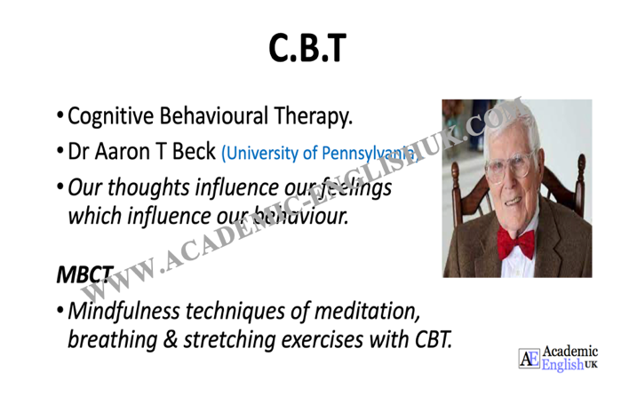
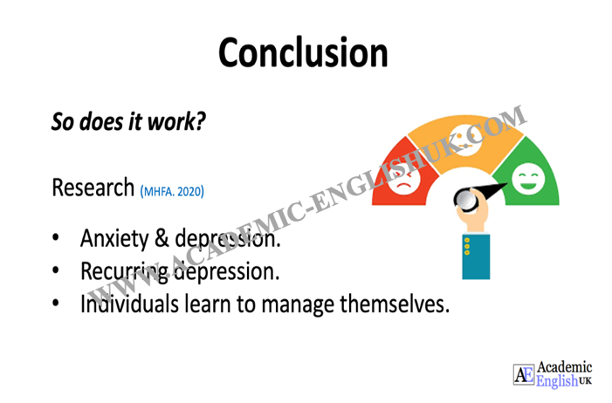

Listening ANSWERS

2.1 Open Questions

i. | How many people have mental disorders per year in England? | 1 in 4
ii. | Name 2 of the 4 factors that cause mental health. | 1.Genetic  2.Biological  …

ALL ANSWERS ARE INCLUDED IN PAID VERSION…

MBCT Lecture Transcript
(C. Watts, 2021)
Hello, I’d like to talk to you today about one of the leading treatments for mental health disorders, MBCT, i.e,. We shall look at exactly what this is a little later in this lecture, as I’d like to start with some important statistics connected to mental health. Mental health is the second largest health burden in…

THE FULL TRANSCRIPT IS INCLUDED IN THE PAID VERSION…

