Describing Results

Example Chart: University Mental Health Statistics
This pie chart has been created from a questionnaire which asked 500 students what the main causes of their mental health issues at university were.

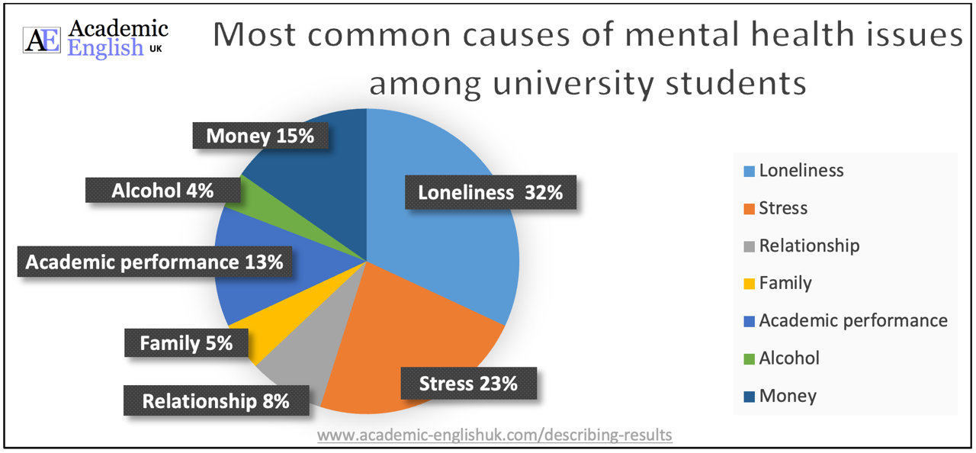

Exercise 1
1. The most significant finding from the questionnaire is that approximately a third of respondents (32%) said that loneliness was the main cause of their mental health issue at university. This was in contrast to a small number of students (4%) saying that alcohol was the main cause.

2. Although the majority of students stated that loneliness and stress were the most significant factors of mental health issues at university at 55%, academic performance and money problems were also reported to be fundamental at 28%.

3. A small minority of students (4%) contended that their mental health issues were attributed to alcohol abuse, whereas a similar number (5%) declared family issues were the main contributing factor.

Exercise 2
1. The most significant finding from the questionnaire is that approximately a third of respondents (32%) said that loneliness was the main cause of their mental health issue at university. This was in contrast to a small number of students (4%) saying that alcohol was the main cause.

2. Although the majority of students stated that loneliness and stress were the most significant factors of mental health issues at university at 55%, academic performance and money problems were also reported to be fundamental at 28%.

3. A small minority of students (4%) contended that their mental health issues were attributed to alcohol abuse, whereas a similar number (5%) declared family issues were the main contributing factor.

Answers go here:
YouTube Video: https://youtu.be/XHr2TBNkmuo

Describing Results Language Development

