Language for Describing Graphs Video Lesson

1. Label the basic parts on this graph

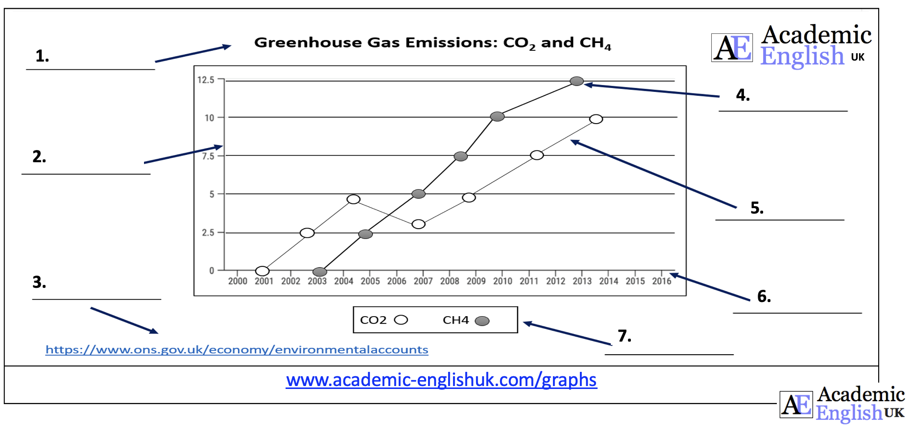

2. Language Review for describing graphs

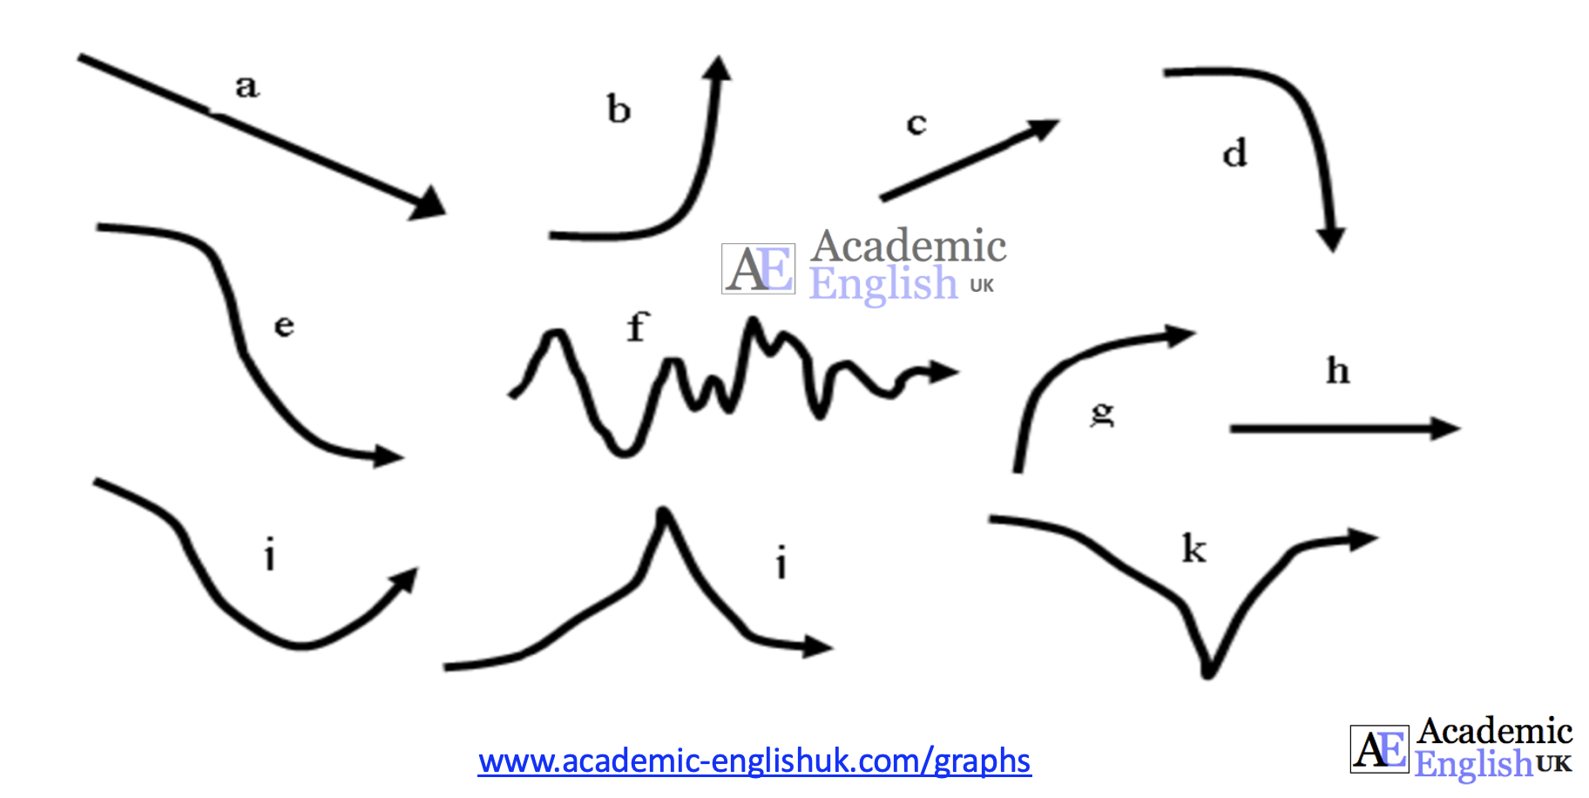

Worksheet Video: https://youtu.be/KctrK8QKTqg
3. Name the different types of graphical lines.
a
b
c | 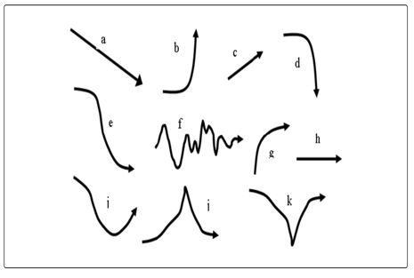
d
e
f
g
h
i
k

4. Language Exercises
Exercise 1
Choose a suitable word from the language review (the number of letters of the word are given):

1. To reach the highest point of development: P e a k
2. To rise very quickly at a high level: S _ _ _
3. To be firmly fixed or not likely to move or change: _ _ _ _ _ _
4. To have a continuous up and down shape or movement: _ _ _ _ _ _ _ _ _

Exercise 2
Choose the correct answer:

1. Energy price shares soared / dipped / stablilised in the first three months of the year at 0.56 but have since recovered to 0.58.
2. The podcast’s audience has plunged / peaked / soared from 5,000 to 80,000 listeners in 1 week.
3. The oil company’s share price fluctuated / plummeted / grew from 27% to 11% in two hours.

Exercise 3
Put a suitable word in the gap:

1. High growth within the economy for 2023 shows that the unemployment rate is remaining extremely _______________ at 2.9%.
2. Vegetable prices tend to _______________ between seasons with higher prices between Nov and March.
3. House prices _______________ in 2022 with an average price of £250,000 and now seem to be _______________at this price after the steep rises over the last few years.
Past Tense Verb Forms
Fill in the table:
Present | Past simple | Past participle
Fall
Rise
Grow
Go up

Graphical Collocations

Verb + Adjective
Fill in the table from the video:
 | Adjective | Verb
A / an | big / considerable / dramatic / gradual / rapid / sharp / significant / slight / small / steady / substantial / threefold / twofold | increase
 |  | decrease
 |  | fall
 |  | rise
 |  | decline
 |  | climb
 |  | drop

Verb + Adverb
Fill in the table from the video:
Verb | Adverb
increase | considerably / exponentially / dramatically / gradually / rapidly / sharply / significantly / slightly / steadily / substantially
decrease
fall
rise
decline
climb
drop
grow

Describe this graph:

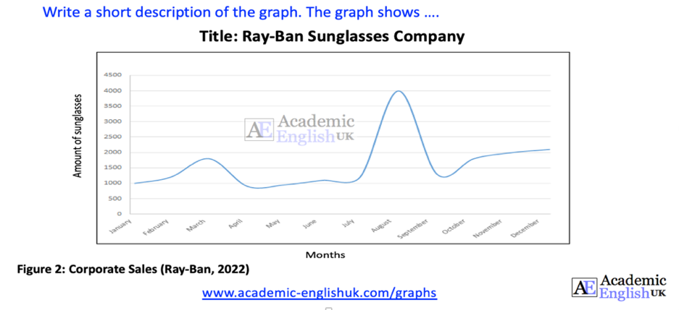
Worksheet Video: https://youtu.be/KctrK8QKTqg

