Describing Graphs (analysis & evaluation) Video Lesson

1. Definition
Write the definition of analysis and evaluation.

Analysis:

Evaluation:

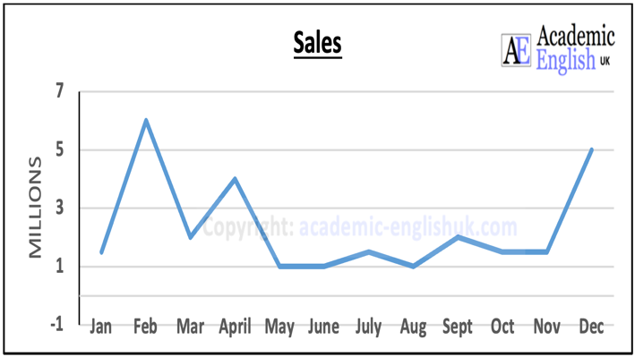 | 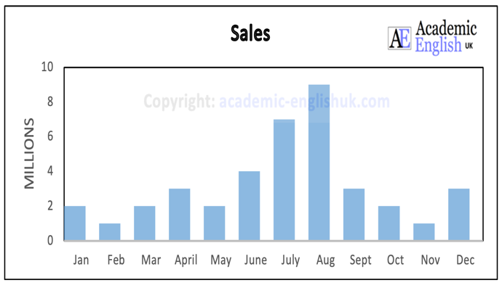

Language Review for describing graphs

1. Describe the graph layout (title / source / axis / key)
The graph from (source) presents data on (title)…
The graph from (source) shows/ illustrates (title)…
If we look at this graph on (title) from (source) you can see...
The y axis (vertical) is… and the x axis (horizontal) is…

Go here for the Describing Graphs (the basics) video: https://youtu.be/KctrK8QKTqg

2. Analysis: describe key points from the graph
Overall summary: Overall, there is / has been… / Generally, there is…
What you can see is… / From the graph we can see...
I’d like to focus your attention on…
If you look at this…, you’ll see / notice..
A key significant area is … / Two key significant areas are…
What is interesting here is...

3.Evaluation: give reasons for the data
This seems to suggest that...
This is possibly because of...
This is (clearly) due to…
One reason for this could be...
An evaluation of this data suggests / provides evidence for
Overall, this highlights the significance of...
A possible future prediction is …

Worksheet Video: https://youtu.be/A8wFn5G98MU
Example

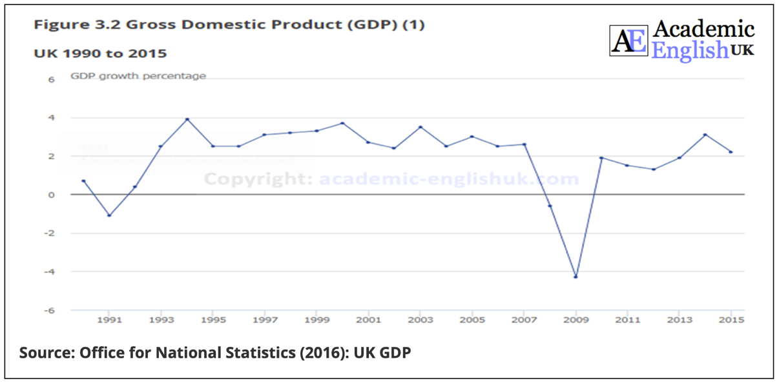

3.Language Structure

The graph from (source) shows/ illustrates (title)…
The y-axis is… and the x-axis is…
Overall, GDP has remained... between…
I’d like to focus your attention on two key significant areas.
(Analysis) The first one is ………. (explain data)
(Evaluation) This is/was possibly because of ….
(Analysis) The second one is ……. (explain data)
(Evaluation) This is / was clearly due to …………
Overall, this graph highlights the evidence that
A future prediction is that……

Practice

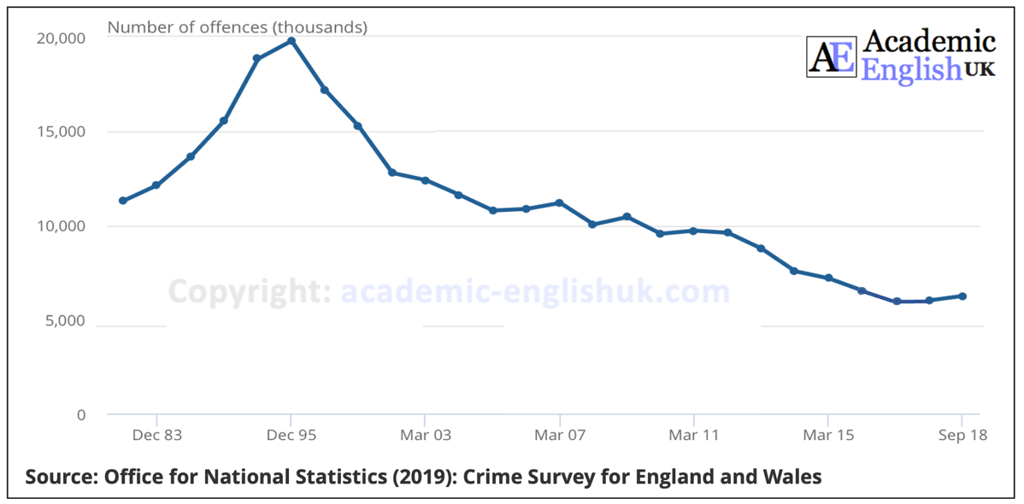

Worksheet Video: https://youtu.be/A8wFn5G98MU

