Text Analysis Video Lesson

1. Write down 4 or five key words associated with critically analysing a text.

Critical Analysis Skills

Higher Order Thinking Skills

Analysis:

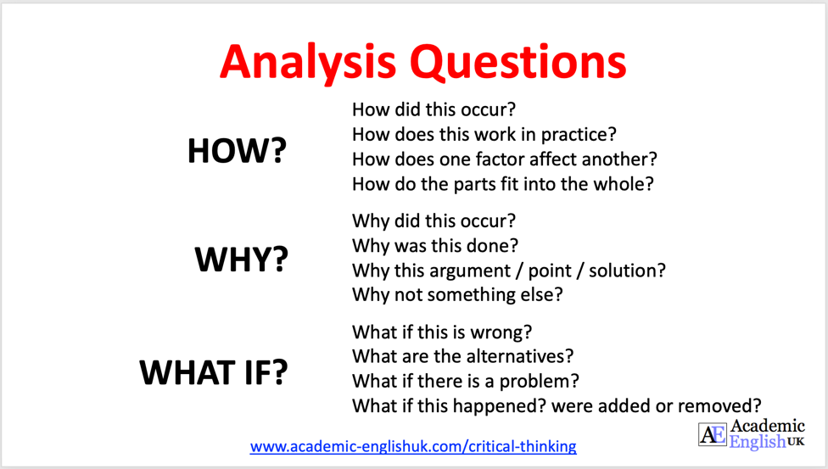

Evaluation:
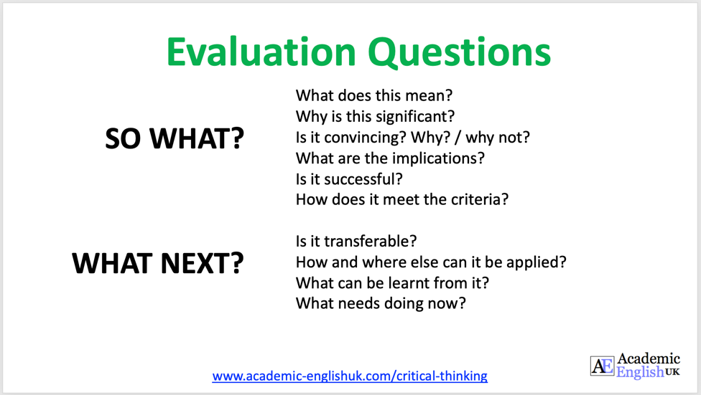

Text Analysis Exercise 1
2. See if you can identify four possible issues within this text. You can also do some internet research if you like to check any of the facts.

Going to university

The UK is the world leader in providing higher education with over 50,000 courses and 395 universities. Higher education has become increasingly popular over the last two decades with most young people choosing to go to university than work. In fact, 2022 saw a record level of 767,000 students attending university for their first year on a degree course. This trend is set to increase year on-year in the future.

1.
2.
3.
4.

Text Analysis Exercise 2
3. See if you can identify three possible issues within this text. You can also do some internet research if you like to check any of the facts.

One of the main reasons for this successful increase is because of the introduction of student loans back in 1996 making university accessible for all. This means that everyone in the UK can attend a university and especially for the students from disadvantaged backgrounds, they can now get themselves out of the cycle of poverty. According to UK Gov (2022) a record 32.5% of people from disadvantaged backgrounds were accepted to university in 2022 compared to 16.1% in 2018.

1.
2.
3.
4.

To buy the whole lesson go here: https://academic-englishuk.com/downloads/critical-thinking-reading-text-analysis-aeuk/

Video: https://youtu.be/GagVokHQ2HA

