Systems of the Human Body

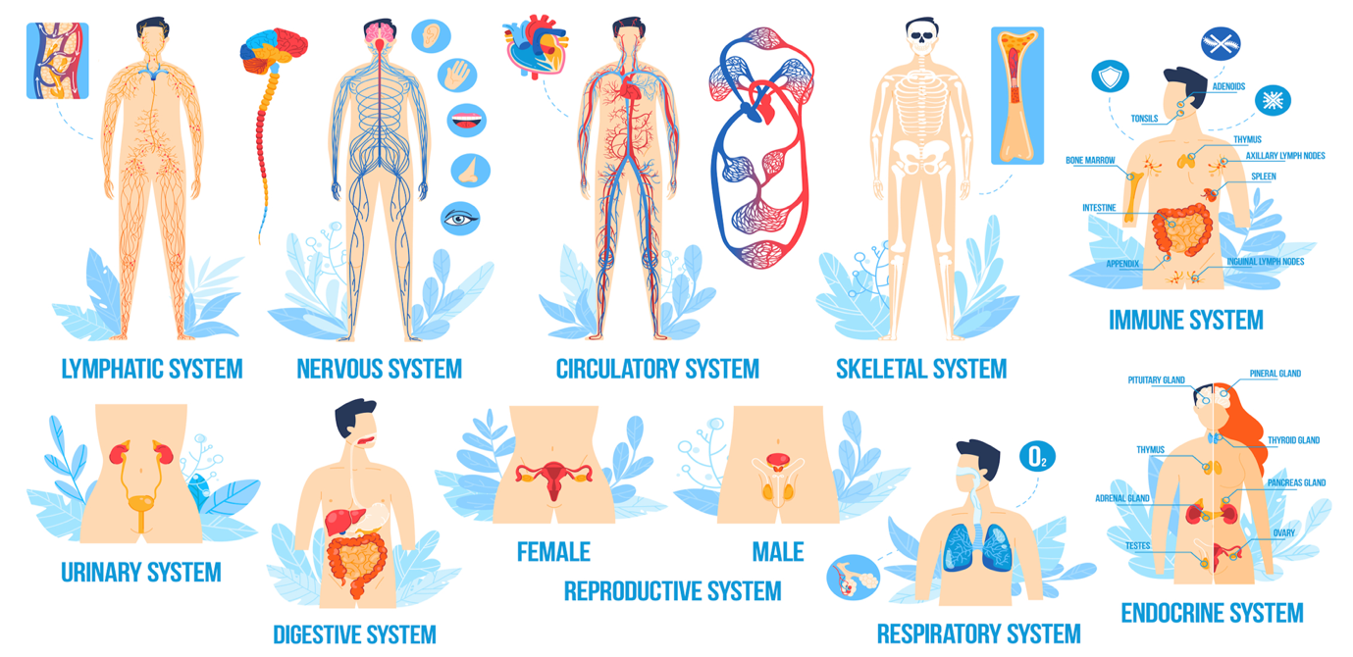

10.Skeletal System
EXAMPLE

Copyright: These materials are photocopiable but we would appreciate it if all logos and web addresses were left on materials. Thank you.
Teacher’s Notes
Lesson aim:
To review/to teach one of the eleven body systems through a range of activities.

Timing:
60 minutes+

Who is this for?
This lesson has been designed as either a range of reviewing/recycling tasks for those that already have some medical knowledge or as a range of activities for those beginning their medical studies.

Level | Medical Knowledge Level | Lesson Ideas | Lesson Timing
All | None | - Pre-teach the vocabulary before each body system.  - Drill pronunciation after each body system.  - Test each body system at the end of each lesson using the test questions at the back of this booklet. Select the questions that are relevant to the body system you wish to test. | 40 mins for the introduction.  50-60 mins per system.
All | Some | - Students can work through each task in small groups or pairs if the teacher does not know how much medical knowledge the students have.  - Drill pronunciation of key medical terms after each body system. | 30 mins for the introduction.  40-50 mins per system.
All | Studied topic previously | Use as a reviewing/recycling task.  Run as a workshop where students are working at their own pace with the teacher feeding in the sample answers when required. | 20 mins for the introduction.  20 -30 mins per system.

Differentiation: Extension ideas
1. Gap fill exercises – remove each table of ‘given’ words.
2. Text boxes – find collocations.
3. Sample paragraph answers – paraphrase or summarise content.
4. Sample paragraph answers – extend the paragraph by researching the organ/system and adding to what has been given.
5. Write a paragraph of other organs or glands in that system.
6. Draw a diagram of an organ and label it.
7. Research an organ and present it to the class.

10. The Skeletal System EXAMPLE
10.1. Label the XXXXXXXXXXXXXXX compare with a partner when you have finished.

1. |  | 2. |  | 3. |  | 4. |  | 5.
6. |  | 7. |  | 8. |  | 9. |  | 10.
11. |  | 12. |  | 13. |  | 14. |  | 15.
16. |  | 17. |  | 18. |  | 19. |  | 20.
21. |  | 22. |  | 23.

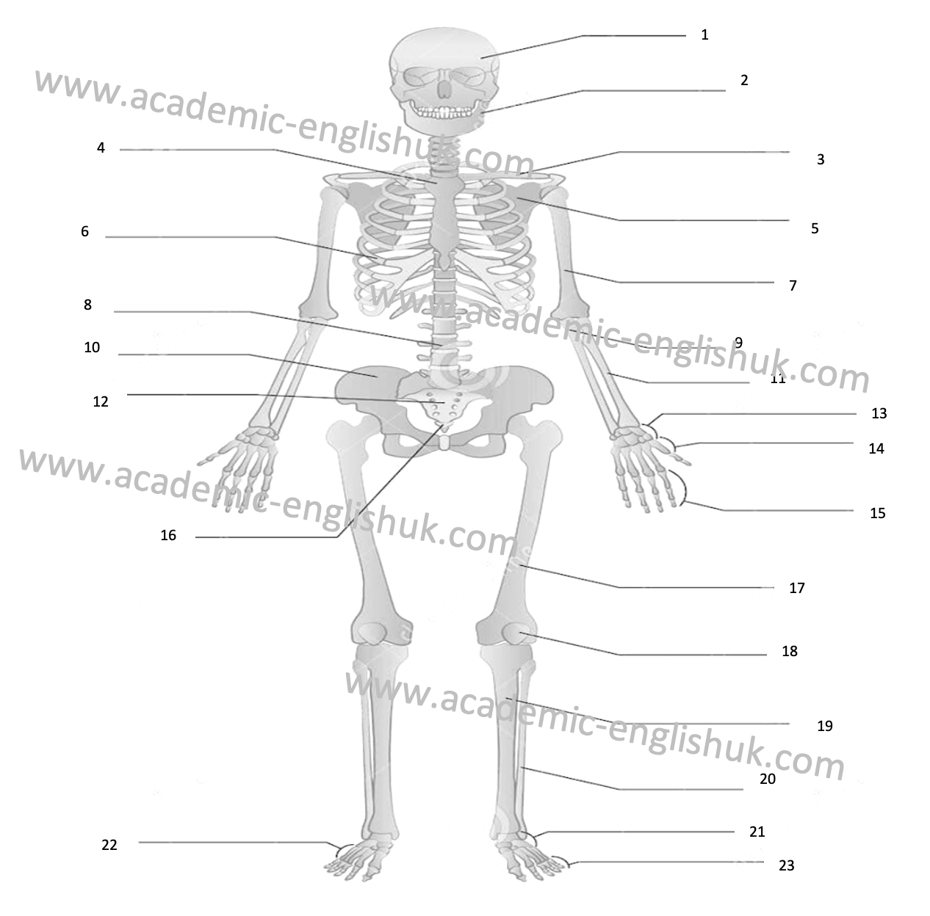

10.2. Practice saying the words aloud with a partner.

10.3. Complete the table of the five types of bones with a partner. The first is done for you.

 | Type of bone | Examples | Function
i. | Flat bones | Skull, thoracic cage & pelvis | To protect the internal organs such as the brain, heart and pelvic organs.
ii.
iii.
iv.
v.

10.4. Write a XXXXXXXXXXXXXXXXXXXXXXXXX about the role of bone marrow using the diagram below.

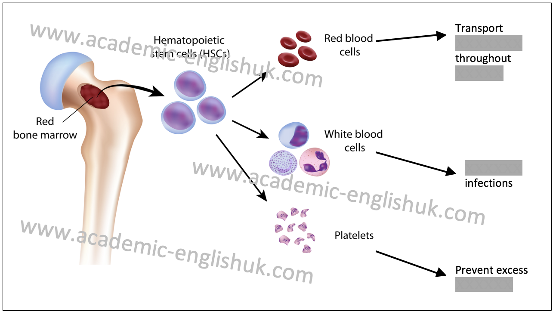

Write your answer here, and then compare with a partner. Is your understanding the same as your partner’s?

10.5. Research task: What can you find out about platelets? XXXXXXXXXXX and then XXXXXXXXXXX

10. The Skeletal System ANSWERS
10.1. Label the human skeleton and compare with a partner when you have finished.

1. | Cranium | 2. | Lower maxilar | 3. | Clavicle | 4. | Sternum | 5. | Scapula
6. | Ribs | 7. | Hum... | 8. | Vert.... | 9. |  | 10.

ALL ANSWERS INCLUDED IN PAID VERSION...

