The top 10 features of academic writing
Video Link: https://youtu.be/11HlWkancMo

1. Features and Language to Avoid in academic Writing

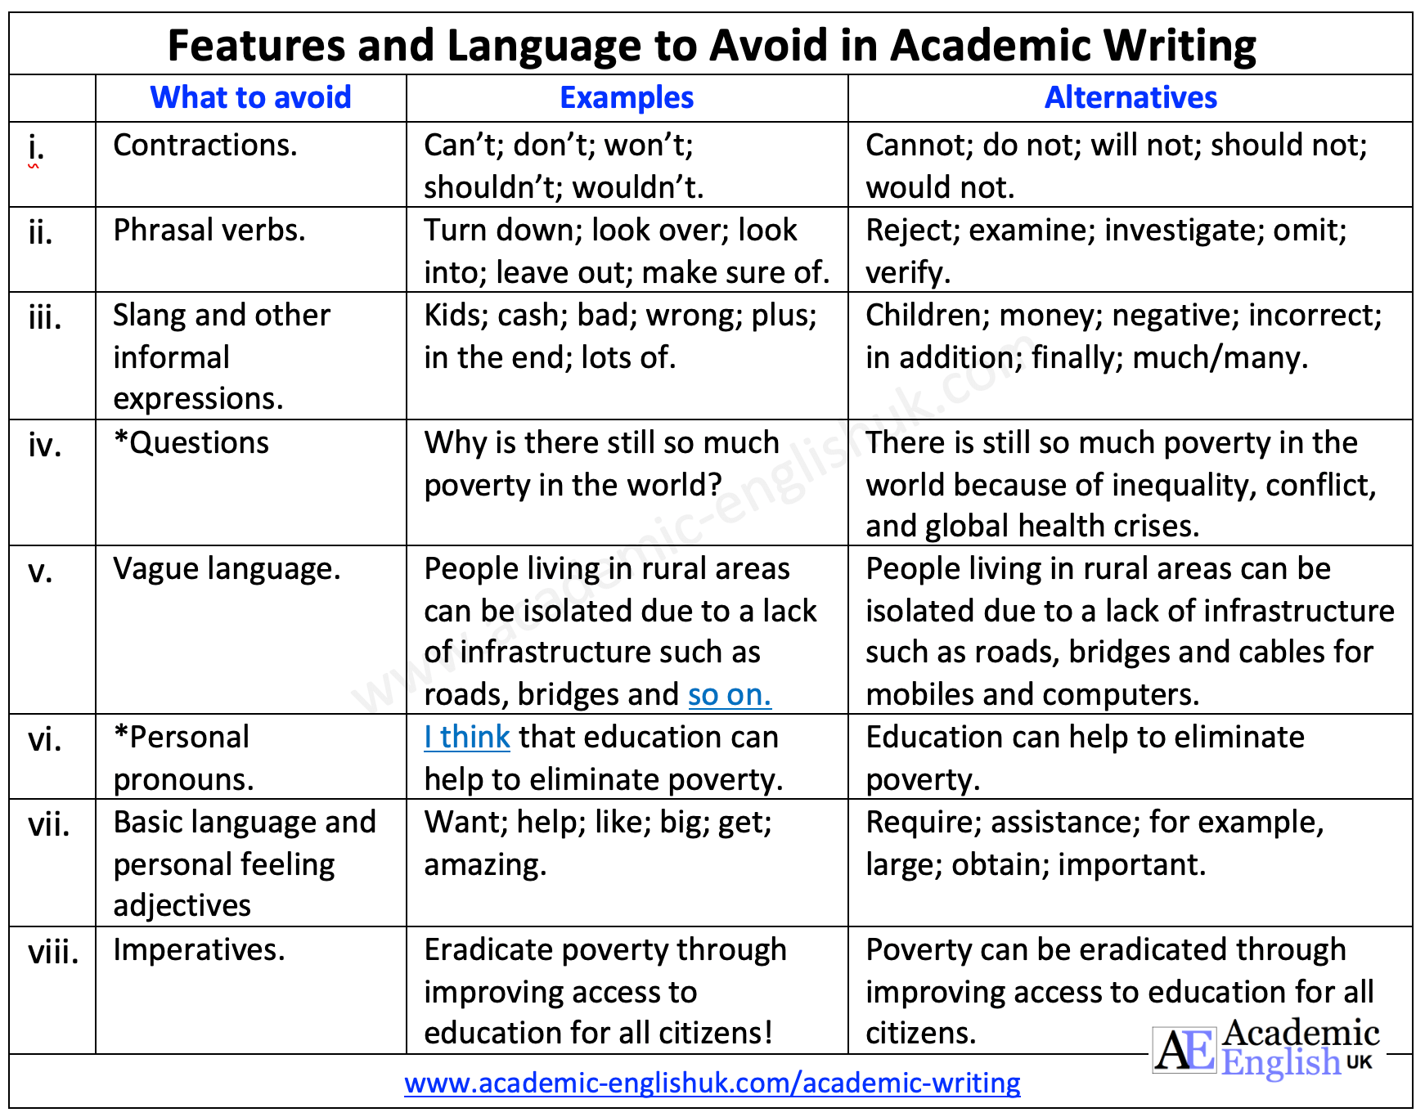

Task: Identify the informal language in each sentence and then rewrite each one

i. | When people don’t have enough food, they lack the strength to work.
ii. | After looking into world poverty, the data illustrates that 8.4% of the world’s population are living in extreme poverty.
iii. | There is enough food to feed everyone in the world. Plus, there are sufficient resources to meet everyone’s needs.
iv. | What happens when people are exposed to contaminated water?

Video link: https://youtu.be/11HlWkancMo
2. Passive

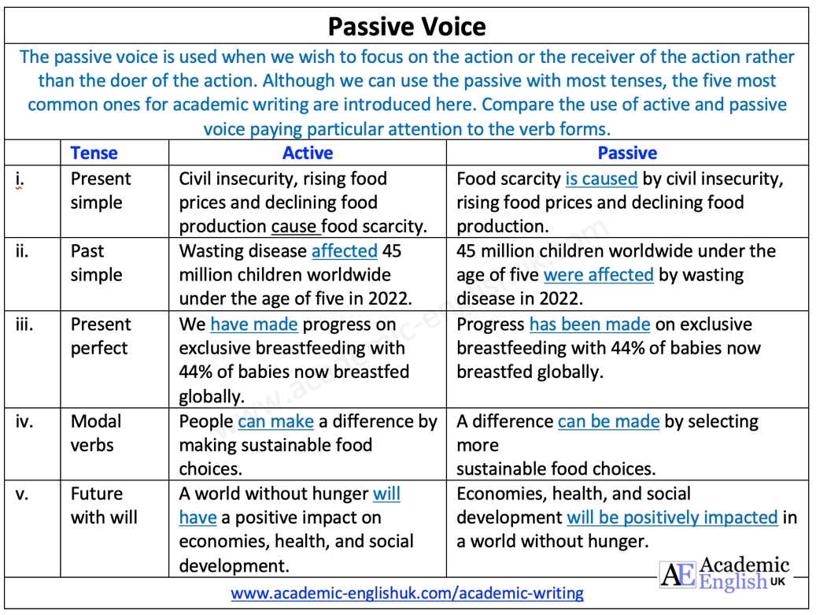

Task: Rewrite the active sentences into the passive voice

 | Tense | Active | Passive
i. | Present  simple | Millions of people in several African countries face famine-like conditions.
ii. | Past  simple | Food insecurity affected over 7 million people in 2021 in South Sudan.
iii. | Present  perfect | Some organisations have offered participants food or money in exchange for completing community projects such as building roads.
iv. | Modal verbs | Microfinance can advance a zero-hunger world.
v. | Future with will | Technology and innovation will solve the issue of global hunger.

3. Hedging

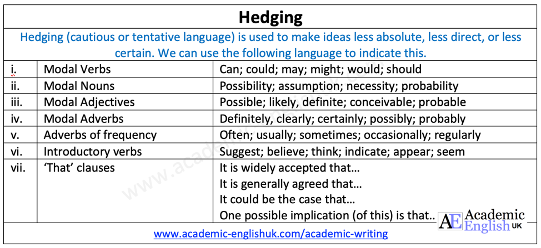

Task: Identify the errors and rewrite the following the sentences

i. | People who recover from Tetanus can caught it again.
ii. | There is a possible that water-borne illnesses can be prevented with good hygiene measures.
iii. | It likely that insecticide-treated bed nets can help in the war against malaria.
iv. | Tobacco use is clear an economic burden with the cost of treating tobacco-related diseases on an upward trajectory.

4. Academic Vocabulary

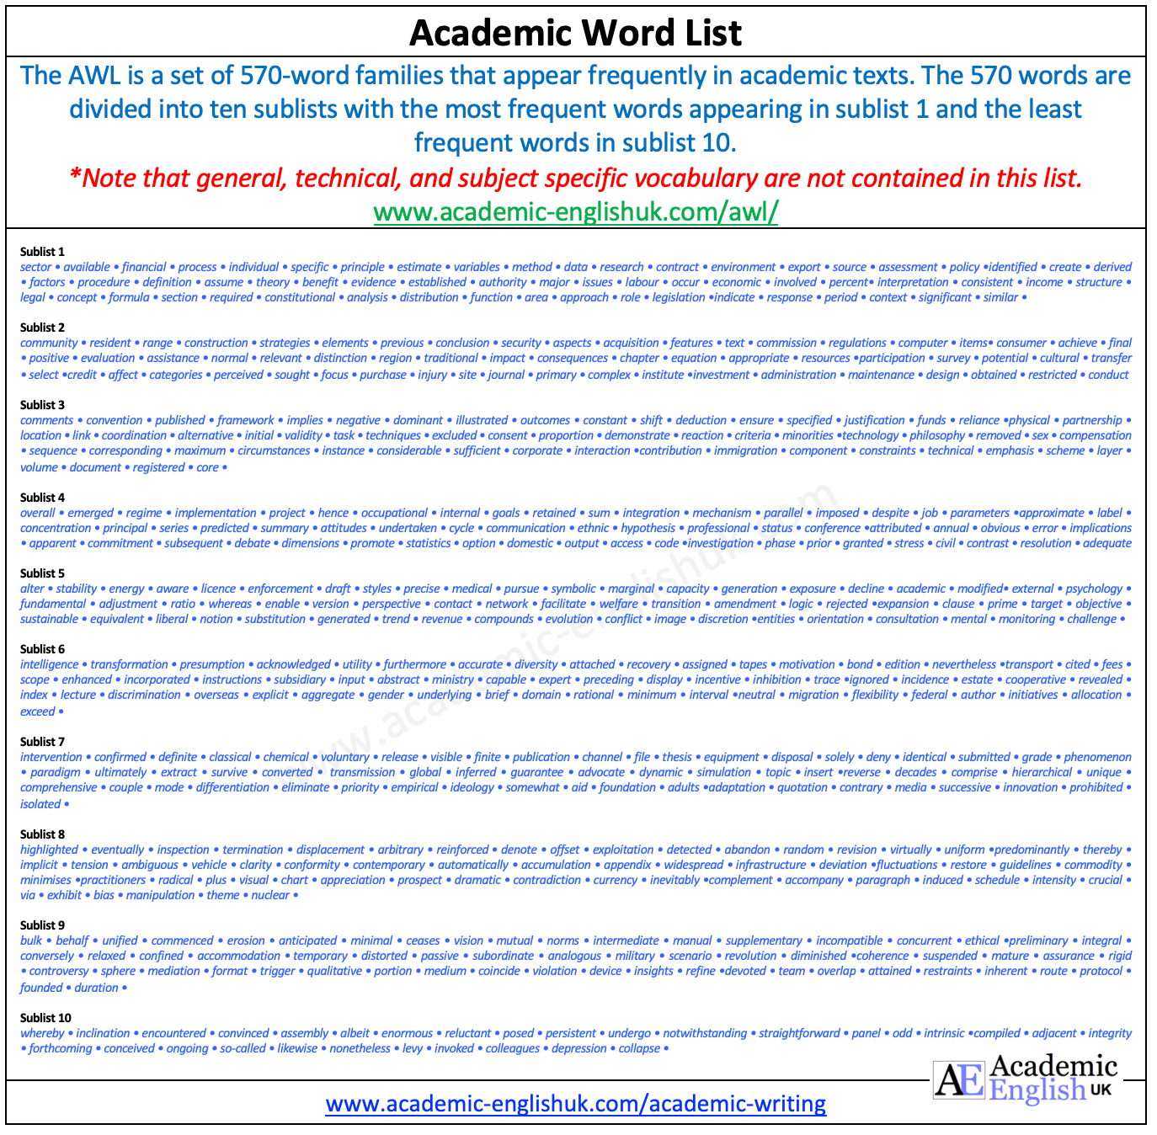

TASK: These words are from AWL sublist 2. Select the best option for each of the following sentences

i. | A common ambition uniting communities/residents across Africa is the desire for a brighter future through education.
ii. | Investment/achievement to protect and promote the rights of adolescent girls in Africa in needed.
iii. | 12 million girls are prevented from completing their studies each year due to the potential/ impact of climate change.
iv. | The consequences/conclusion of large class sizes is that they result in lower educational accomplishments.
v. | Insufficient learning resources/strategies such as course books are hindering the education of millions of children each year in Sub-Saharan Africa.

5. Noun Phrases

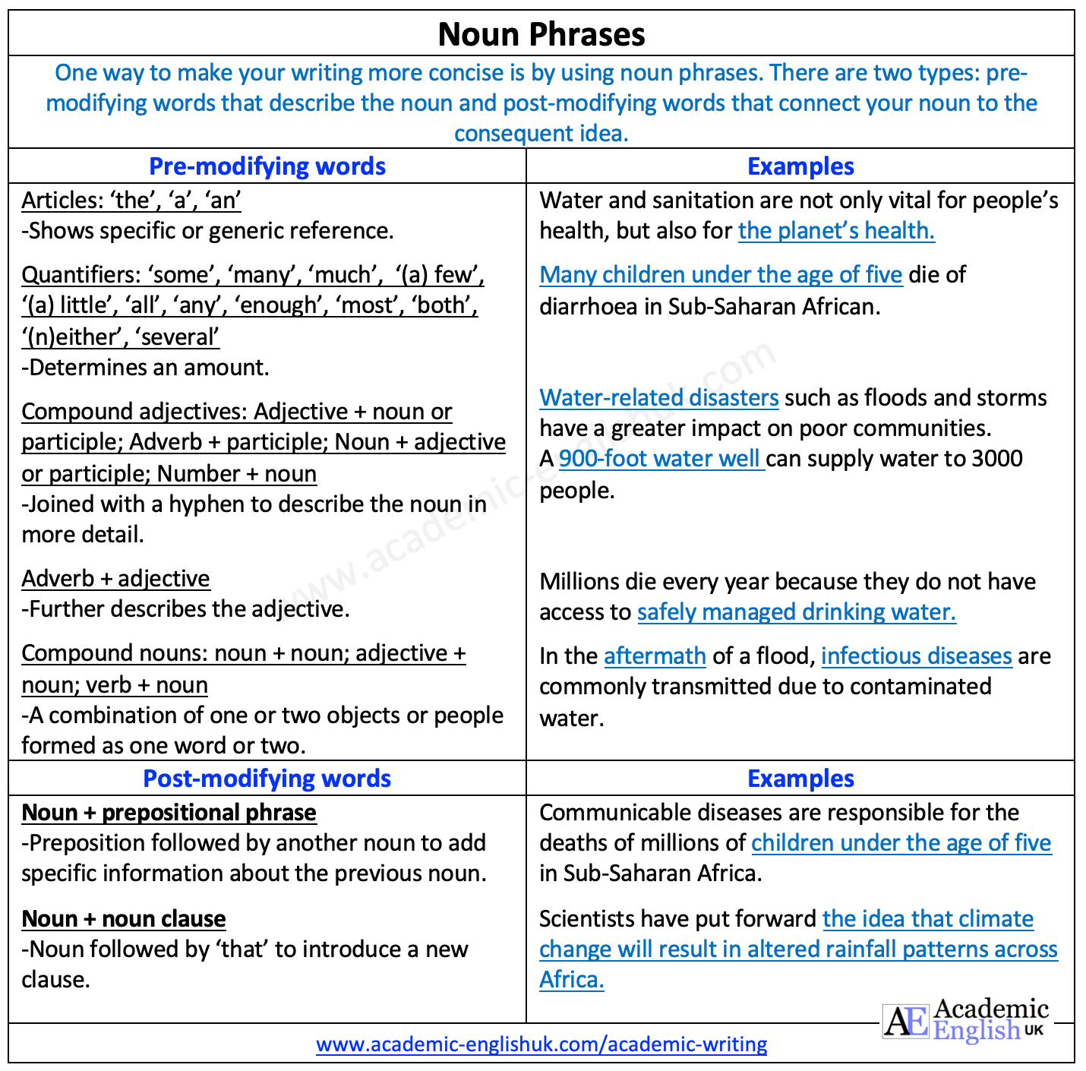

Task: Rewrite the following sentences on ‘water-related disasters’ so that the articles are accurate

i. | An impact of disasters is worsening due to urbanisation.
ii. | One effect of rapid urbanisation is that water drainage has become the real challenge.
iii. | After an flood, outbreaks of infectious diseases are common.
iv. | Over a last 50 years, there have been more water-related disasters than any other natural disaster.
v. | Climate change is predicted to increase a number of people affected by flooding.
vi. | A spread of water-borne diseases such as cholera and typhoid are associated with drinking contaminated water.
6. Complex Language Structures

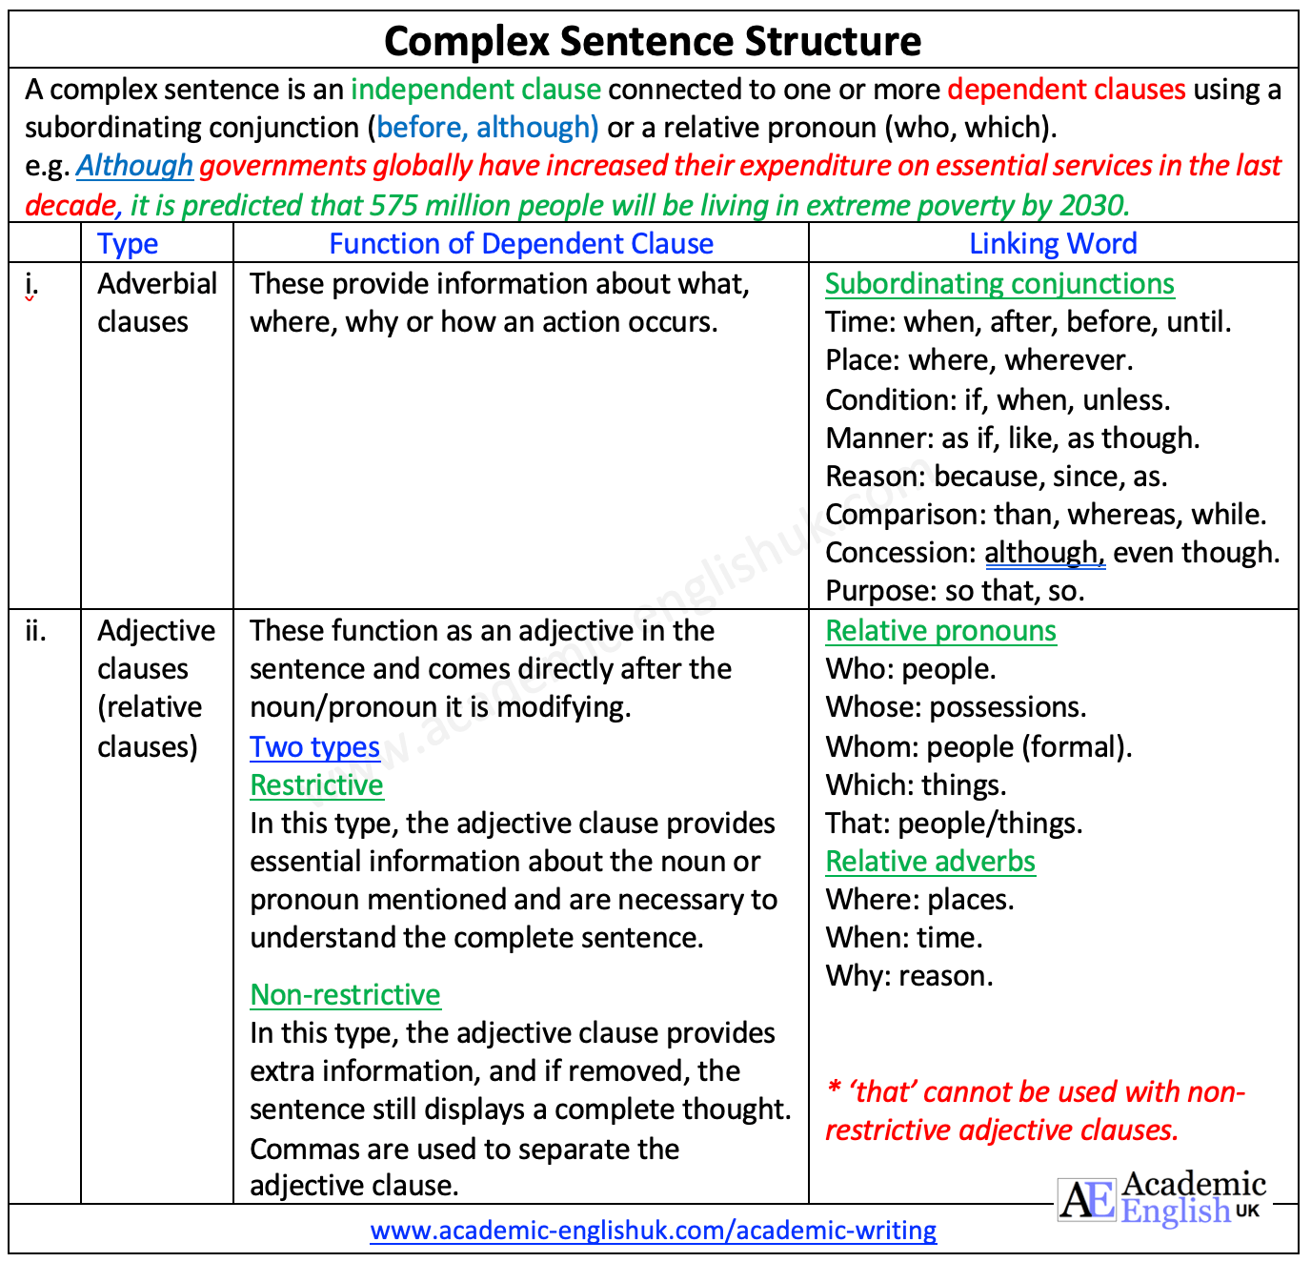

Task: Combine the two clauses to make one sentence using a subordinating conjunction.

i. | a. | Many fossil fuels are exported.
i. | b. | They are subjected to price fluctuations.
ii. | a. | Africa is abundant in renewable energy sources such as wind and solar.
ii. | b. | They are underutilised.
iii. | a. | Half the population of African has access to electricity.
iii. | b. | Efforts to connect the rest are hampered by population growth.
iv. | a. | Africa changes their coal and oil plants to run on natural gas.
 | b. | It could reduce its emissions and increase energy access.
7. Cause and Effect Language

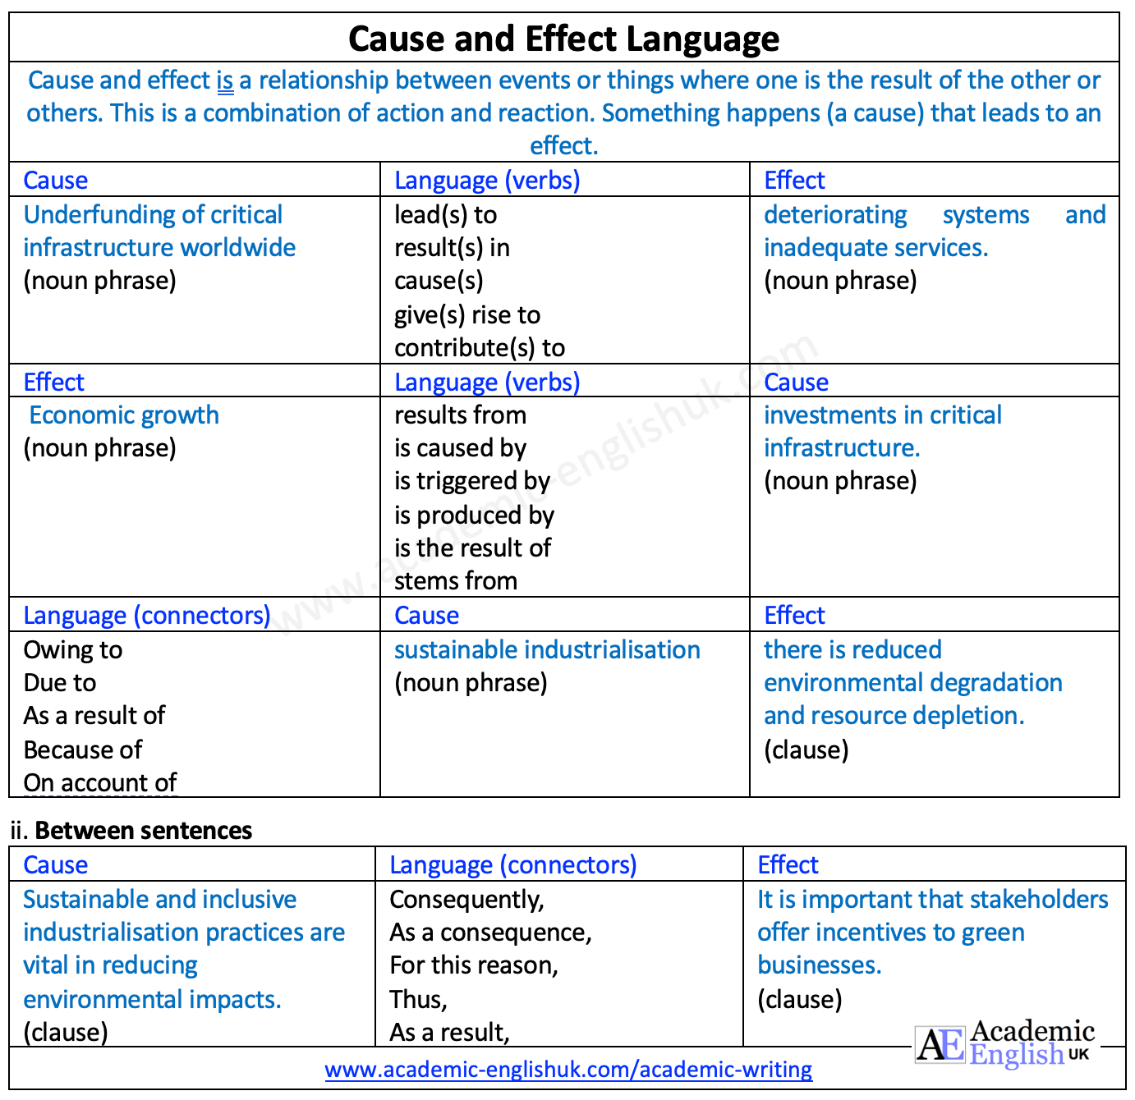

Task: Select the correct cause/effect language in the following sentences about ‘digitalisation’.

i. | Digitalisation can be attributed to/is caused by socio-economic change in Africa.
ii. | Socio-economic change stems from/plays an important role in opening up new job opportunities.
iii. | The creation of jobs within data analytics, machine learning and digital marketing will result in/is triggered by African youths being able to shape their futures and drive economic growth.
iv. | On account of/as a consequence job opportunities in technology requiring a higher level of education, a skills shortage could be seen across the sector.
v. | Updated curricula to include digital skills training will stem from/will contribute to preparing students for employment in the digital age.

8. Parallelism

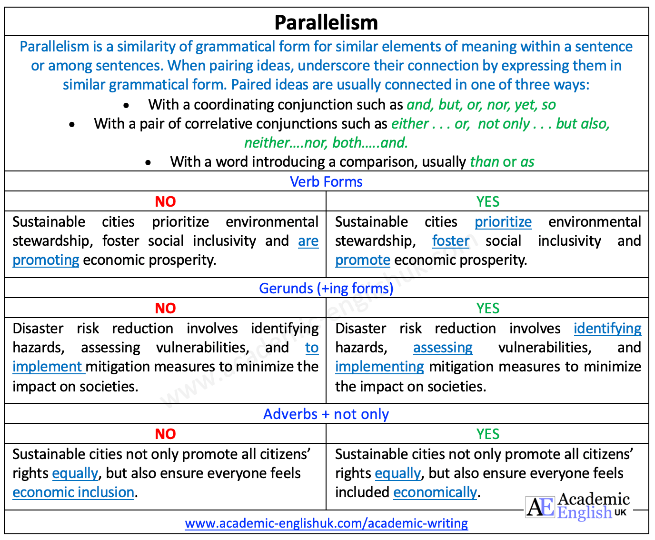

TASK: Read the following sentences about ‘sustainable cities’ and highlight the parallel structures in RED

i. | Growing populations, changing environments, and increasing urbanisation have led to the need for cities to radically change in order to be resilient to climate change.
ii. | Poor housing conditions are not only associated with health issues, but also with environmental hazards.
iii. | The level of pollution is far higher in informal settlements than it is in formal settlements.
iv. | Enhancing urban adaptability is vital in avoiding human, social and economic losses.
v. | A sustainable city is an urban area designed to meet the needs of its inhabitants by minimising environmental impact, fostering economic growth, and ensuring social equity.

9. Coherence

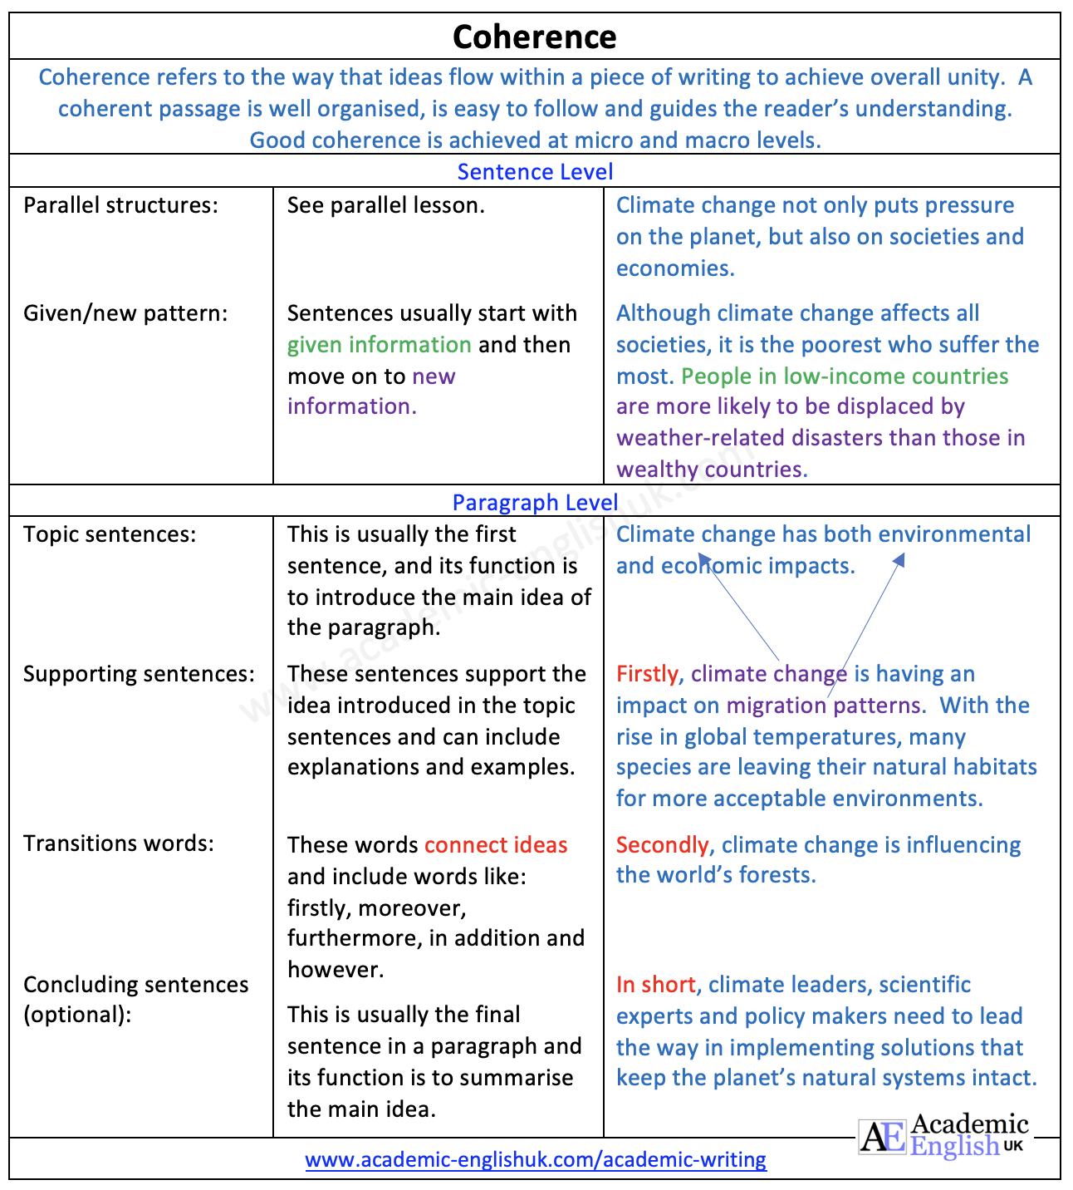

Task: Identify given/new pattern in the following paragraph. Highlight the given information in green and the new information in purple.

Climate change is a growing threat to biodiversity in various ways. Firstly, rising temperatures affect coral reef ecosystems considerably. Corals can become stressed by changes such as temperature and light, and when this happens, they remove the algae living in their tissues, causing the coral to turn white. This process, known as bleaching, can lead to diseases or even death. Secondly, changing climate conditions are creating new ways for the introduction and spread of invasive species. These organisms have a negative effect on the native biodiversity as they damage habitats, spread new diseases and cause extinction. In summary, an observational approach is needed to monitor ecosystems, and detect and identify new invasions.

10. Cohesion

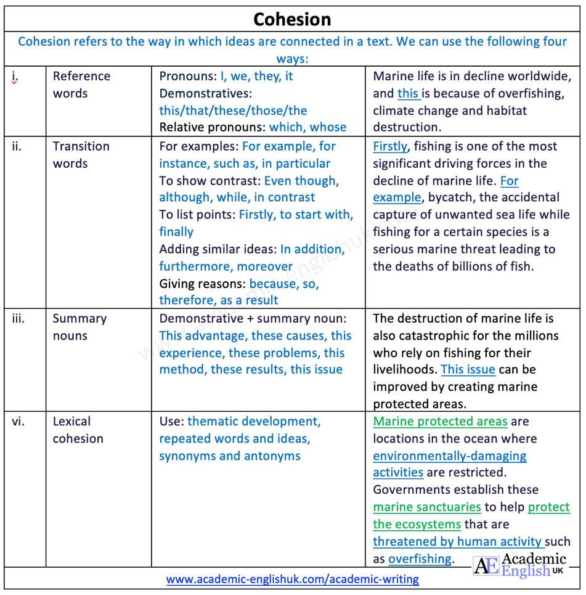

Task: Complete the gaps in the following sentences about ‘ocean energy’ with a transition word from the box.

such as even though however apart from for example because to start with since

i. | The ocean can provide several forms of renewable energy such as tidal, wave and wind energy.
ii. | Offshore wind and ocean energy do not contribute to global warming because they do not emit CO2 or other greenhouse gases.
iii. | Even though tidal energy is a reliable source of energy, it is not popular at present.
iv. | The latest generation of wind technology is the floating offshore wind farm, and since these are less damaging to the seabed, they are more advantageous.
v. | Apart from the environmental benefits of ocean energy, there are economic benefits too.
vi. | To start with, the implementation of ocean energy will be instrumental in job creation.
vii. | Opportunities will arise for skilled labour in, for example, installation.
viii. | The countries that invest in ocean energy, however, will be the ones who will benefit economically.

