Describing Paintings Video Sheet
Video link: https://youtu.be/iGBk2gS1uy8
Different styles in painting
What do you know about these different styles? Add some notes to the description column.

 | Style | Description
1 | Renaissance
2 | Baroque
3 | Rococo
4 | Neoclassicism
5 | Romanticism
6 | Realism
7 | Impressionism
8 | Post-Impressionism
9 | Expressionism
10 | Cubism
11 | Surrealism
12 | Abstract Art
13 | Pop Art
14 | Minimalism
Describing Paintings: Language Phrases for Describing Paintings
When describing paintings, we usually focus on four areas: general description, style and technique, colours and mood, and personal interpretation. Below are useful English phrases for each.

1. General Description
This painting shows / depicts / portrays…
The artwork represents…
It is a portrait of… / It is a landscape of…
The scene is set in…
It appears to be…

2. Talking about Style & Technique
It was painted in the [Renaissance / Impressionist / Cubist / etc...] style.
I think it was painted by (artist’s name)…and is called…
The artist uses bright / muted / contrasting / earthy / colours.
The brushstrokes are bold / delicate / expressive / loose / full of movement / precise...
The composition is balanced / symmetrical / fragmented with…
It is painted in oil / watercolour / fresco / acrylic on canvas.

3. Colours & Mood
The dominant colours are…
The use of light creates a dramatic / calm / mysterious / striking / unsettling / stark / effect.
The colours give the painting a warm / cold / vibrant / monumental / formal / serious atmosphere.
The mood of the painting is joyful / melancholic / unsettling / reflective / tense / austere / serene.

4. Interpretation & Personal Response
The painting might symbolise…
It could reflect the artist’s feelings about…
It makes me feel…
I like this work because…
This reminds me of…

Practice

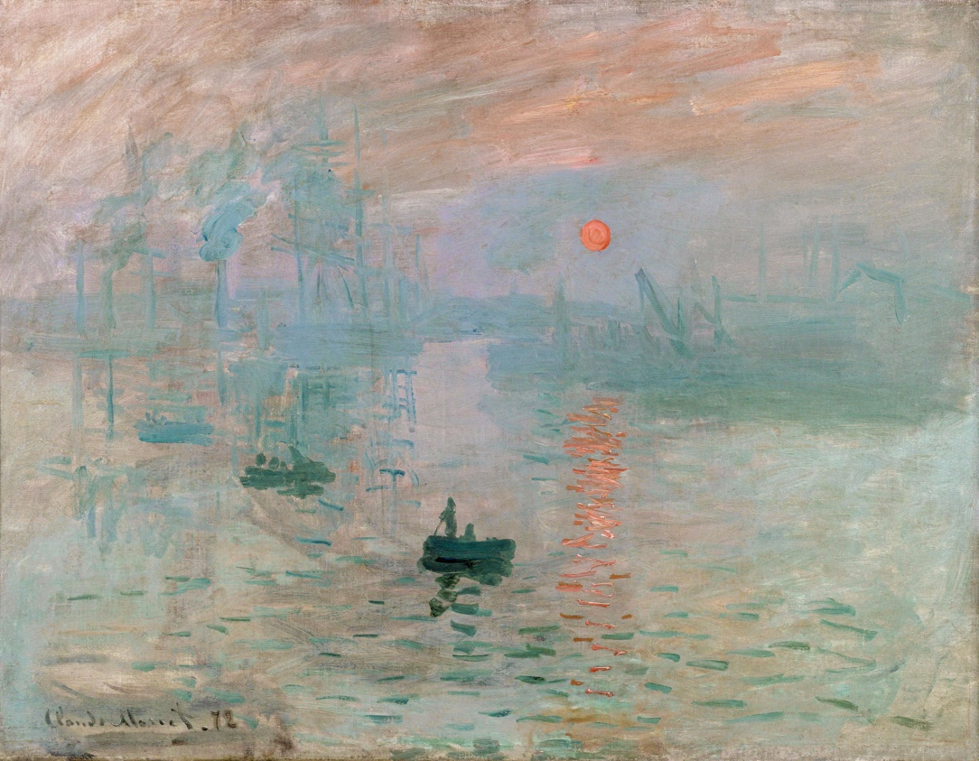

1. General Description
This painting shows / depicts / portrays…
The artwork represents…
It is a portrait of… / It is a landscape of…
The scene is set in…
It appears to be…
2. Talking about Style & Technique
It was painted in the …… style.
I think it was painted by (artist’s name)… and is called…
The artist uses … colours of…
The brushstrokes are….
The composition is … with…
It is painted in….
3. Colours & Mood
The dominant colours are…
The use of light creates a …. effect.
The colours give the painting a … atmosphere.
The mood of the painting is …
4. Interpretation & Personal Response
The painting might symbolise…
It could reflect the artist’s feelings about…
It makes me feel…
I like this work because…
This reminds me of…

Video link: https://youtu.be/iGBk2gS1uy8

