
The General Features of Digital Learning



Lesson 1
Sentence Accuracy - Identifying Errors
FREE VIDEO LESSON

Copyright: These materials are photocopiable but we would appreciate it if all logos and web addresses were left on materials. Thank you.
Lesson 1: Sentence Accuracy - Identifying Errors
Aims of the lesson
By the end of this lesson, you will be able to:
- identify common grammatical errors in academic sentences.
- correct errors accurately and independently.
- use AI tools responsibly to support learning.
- VIDEO: https://youtu.be/Qbtd5cGCwH4

- Note: The theme of this lesson is ‘the general features of digital learning’. Read the following definition and check any words that you do not know.

Digital learning environments are online or blended spaces where teaching and learning take place using digital technologies. These environments typically include platforms for content delivery, communication and assessment.

Task 1: Noticing accuracy
Each sentence below contains ONE grammar error. Identify it and rewrite the sentence correctly.
- Hint: focus on subject-verb agreement.
 | Sentence | Rewrite
1. | 
2. | 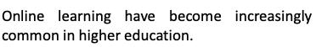
3. | 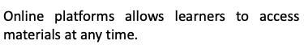
4. | 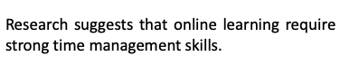
5. | 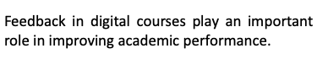

Task 2: Sentence editing practice
The paragraph below contains TEN grammar errors. Find and correct them.
- Hint: focus on subject verb agreement and singular vs plural nouns.

Original Paragraph
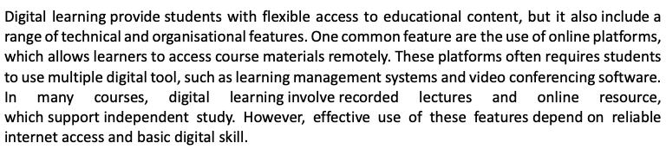

Revised Paragraph
Task 3: AI-supported error identification
Now use an AI tool such as ChatGPT or M365 Copilot to support your learning. Use these exact steps.

Step1. | Copy your corrected paragraph into your chosen AI tool and copy this prompt exactly as it is written:  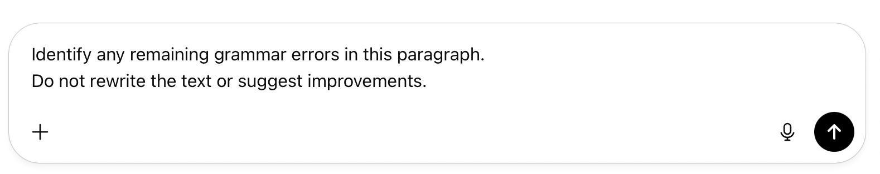
Step2. | Compare the AI feedback with your corrections by answering these questions:
Step2. | i. | Did the AI identify any errors you missed? What were they?
Step2. | ii. | Did it incorrectly identify anything as an error?
Step2. | iii. | What grammar point do you need to review?

Task 4: Independent writing
Write FIVE academic sentences on ‘the general features of digital learning’.
Guidelines
- Focus on grammar accuracy, not complexity.
- Focus on subject-verb agreement and singular/plural nouns.
- Write clear, complete sentences.
⚠ Do NOT use an AI tool while writing.
Your Sentences
1.
2.
3.
4.
5.

Task 5: Feedback
Step 1: Check your own writing
Read your sentences and tick (✓) the statements that are true.
1. | All verbs agree with their subjects.
2. | Singular and plural nouns are used correctly.

Step 2: Use an AI tool to support your learning
Copy and paste your sentences and the following prompt into the AI tool.
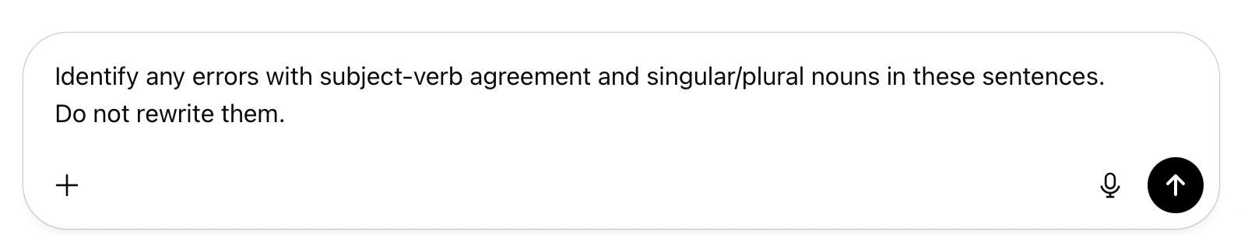
Task 6: Reflection
How did using AI help you identify or confirm sentence-level errors in this lesson? Give ONE specific example.

VIDEO: https://youtu.be/Qbtd5cGCwH4

