

Benefits and Limitations of AI in Education

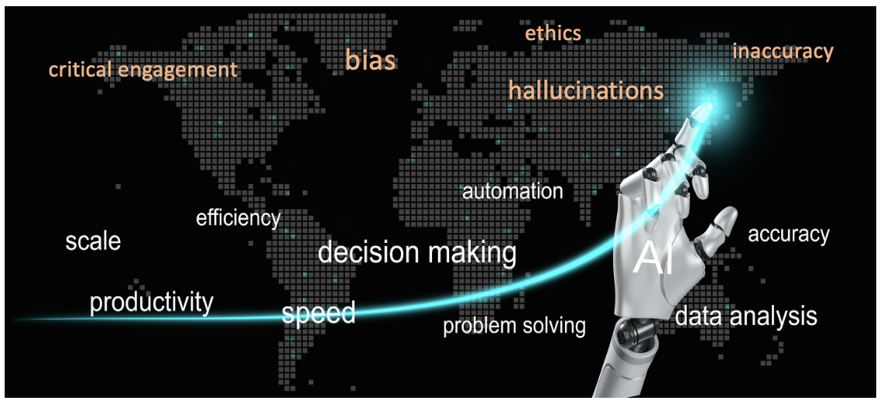

Lesson 4

Recognising Stance and Hedging
FREE VIDEO LESSON

Copyright: These materials are photocopiable but we would appreciate it if all logos and web addresses were left on materials. Thank you.
Lesson 4: Recognising Stance and Hedging

Aims of the Lesson
By the end of this lesson, you will be able to:
- recognise whether a writer’s stance is positive, cautious, or critical.
- identify common hedging language used in academic texts.
- distinguish between strong claims and cautious academic claims.
- evaluate AI feedback on writer stance critically.
- Video: https://youtu.be/kQiPkfDvr_M

Task 1: Noticing writer’s stance
Read the paragraph below. Underline words or phrases that show the writer’s stance towards AI in education and decide whether the overall stance is positive, cautious or critical. Write your answer in the following box.

Reading Text 1
AI tools are increasingly used in higher education to support teaching and learning. These tools may enhance efficiency by providing faster feedback and personalised learning pathways. However, concerns have been raised about data privacy and the potential over-reliance on automated systems. As a result, many institutions appear to be adopting AI cautiously rather than fully integrating it into all aspects of education.

 | Positive ✓ | Cautious ✓ | Critical ✓
The writer’s stance is:

Task 2: Identifying stance and hedging
Look again at the paragraph in Task 1 and answer the questions below:

1. | Which words or phrases reduce the strength of the claims?
2. | Which sentence introduces a limitation or concern?
3. | Why do you think the writer avoids strong or absolute language?

Task 3: AI-supported stance and hedging check
Now use an AI tool to support your learning.

 | Step
1. | Copy reading text 1 into your chosen AI tool and copy this prompt exactly as it is written:  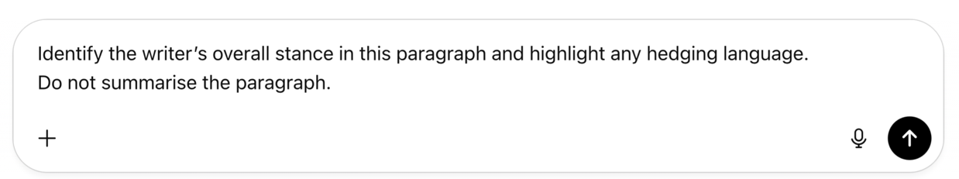
2. | Compare the AI’s response with your answers by completing these questions:
2. | i. | Did the AI identify the same stance as you?
2. | ii. | Did it highlight the same hedging expressions?
2. | iii. | Do you agree with the AI’s interpretation? Why or why not?

Task 4: Independent transfer
Read the paragraph below. Decide whether the writer’s stance is positive, cautious, or critical. Underline any words or phrases that show hedging.
⚠ Do NOT use an AI tool for this task.

Reading Text 2
AI-driven study support tools are increasingly used in higher education to guide independent learning. These tools can be understood to facilitate the recommendation of resources and study strategies based on learner behaviour, helping students focus on areas where additional support is likely to be beneficial. When integrated with clear guidance and thoughtful course design, automated study support has the potential to encourage more targeted engagement with course content and is expected to contribute to the development of students’ ability to manage their own learning effectively.

 | Positive ✓ | Cautious ✓ | Critical ✓
The writer’s stance is:

- Do NOT compare your answers with your classmates. Move on to the next exercise.

Task 5: Feedback
Step 1: Check your own work
Read your answers from task 4 and tick (✓) the statements that are true.

1. | I identified the writer’s overall stance accurately.
2. | I recognised hedging language rather than strong claims.
3. | I recognised both positive points and limitations expressed by the writer.

Step 2: Use an AI tool to support your learning
Copy reading text 2 and the following prompt into the AI tool.
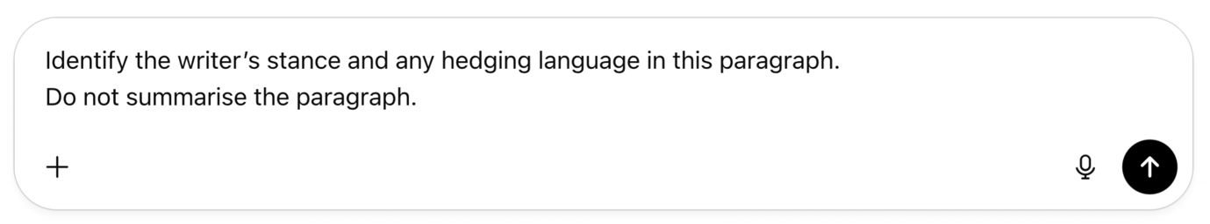
Task 6: Reflection
How did using AI help you confirm or question your understanding of writer stance and hedging in this lesson? Give ONE specific example.

- Discuss your answers with your classmates and your teacher.

Task 7: Optional extension task
Read the text below and identify the stance and hedging language.
⚠ Do NOT use an AI tool for this task.

Reading Text 3
The use of AI-generated feedback on short academic tasks is increasingly discussed within higher education contexts. Although this approach is often promoted as a way of providing timely responses to student work, particularly in large courses where individual feedback is limited, its educational value remains contested. AI systems are generally limited to identifying surface-level features such as recurring language errors or incomplete responses, which offers only partial support during early stages of task completion. As a result, AI feedback is more accurately viewed as a constrained supplement to human input rather than a meaningful alternative.

Moreover, AI-generated comments are typically based on pattern recognition and do not consistently account for task purpose or disciplinary expectations. There is also a growing concern that students may rely on automated feedback without critically evaluating its relevance or accuracy. Taken together, these limitations indicate that AI feedback should be treated with caution and carefully embedded within a broader learning framework. Even when used selectively and with guidance, its contribution to student learning appears uneven and is likely to depend more on student interpretation than on the capability of the technology itself.

- Apply the strategies you learned in this lesson to check your answers.

BUY the 10-Lesson Ai-supported Academic Reading Workbook
https://academic-englishuk.com/downloads/ai-supported-academic-reading-10-lesson-workbook-download/

